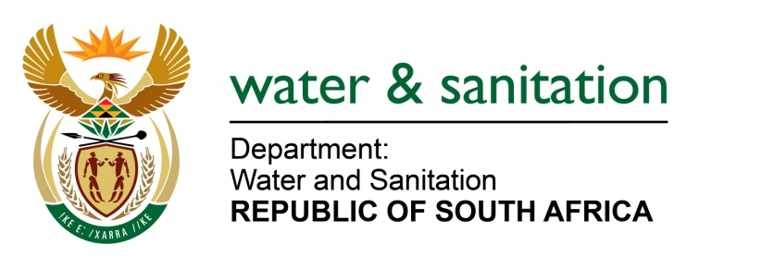

NATIONAL ASSEMBLY

FOR WRITTEN REPLY

QUESTION NO 1913

DATE OF PUBLICATION IN INTERNAL QUESTION PAPER: 22 MAY 2015
(INTERNAL QUESTION PAPER NO. 15)
1913. Ms S V Kalyan (DA) to ask the Minister of Water and Sanitation:

(a) Who are the current chief financial officers of (i) her department and (ii) the entities reporting to her and (b) what is the qualification of each chief financial officer? NW2134E
---00O00---
REPLY:
Refer to the table below for the current Chief Financial Officers of the Department and the Entities:
Department/ Entity | Full Names | Qualifications
Department: CFO Water Trading Entity | Mr Mpho Mofokeng | B Tech: Cost & Management Accounting Degree
Department: CFO Main Account | Ms Nthabiseng Fundakubi | B Tech: Business Administration
Amatola Water | The CFO post is vacant. | N/A
Bloem Water | Mr OJ Stadler | B Comm Honours; Masters in Business Leadership (MBL)
Lepelle Northern Water | Mr JC Kilan | Honours: Accounting; Masters in Business Administration
Magalies Water | Ms A Raphela | B Comm Honours; Chartered Accountant
Mhlathuze Water | Mr B Ndaba | (b) B Comm (Accounting)
Overberg Water | Ms A Cilliers | B Compt, B Compt Honours; Chartered Accountant
Rand Water | Mrs SM Nyembe | B Comm (Accounting); B Compt Honours
Sedibeng Water | Ms MA Shasha | B Compt Honours
Umgeni Water | Mr TB Hlongwa | B Comm (Accounting); B Comm Honours (Accounting); Chartered Accountant
Inkomati-Usuthu CMA | Ms Thembelihle Mjaji | Qualified Chartered Accountant.  Honours in Bachelor of Accounting Science  Degree in Bachelor of Accounting Science
Breede Gouritz CMA | Mrs. Judith Ntombizanele Nkomombini | Bachelor of Commerce

---00O00---

