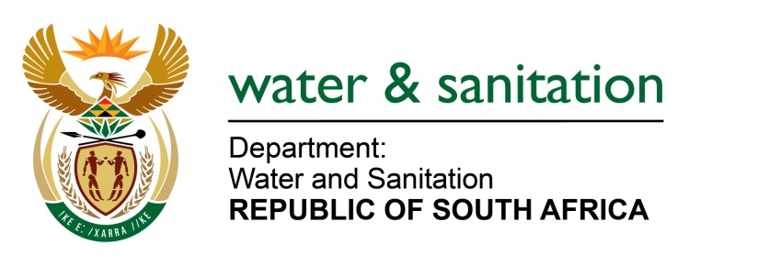

NATIONAL ASSEMBLY

FOR WRITTEN REPLY

QUESTION NO 1912

DATE OF PUBLICATION IN INTERNAL QUESTION PAPER: 16 SEPTEMBER 2016
(INTERNAL QUESTION PAPER NO. 28)

1912. Mr K P Robertson (DA) to ask the Minister of Water and Sanitation:

With reference to her letter of 27 August 2016, addressed to Mr KP Robertson, (a) which (i) waste water treatment plants and (ii) sewerage pipelines are due to be (aa) upgraded and/or (bb) refurbished in the Chief Albert Luthuli Local Municipality in Mpumalanga, (b) by when are the specified improvements due to begin and (c) what portion of the R25 million allocated by her department through the Municipal Infrastructure Grant will be used in each case? NW2223E
---00O00---
REPLY:

Refer to the table below:

(a)(i) Name of Waste Water treatment plant | (a)(ii) (aa) Sewerage pipelines upgrade | (a)(ii) (bb) Sewerage pipelines refurbished | (b) Due date for specified improvements to begin | (c) Allocation through MIG
Emanzana phase II Waste Water Treatment Works (WWTW) | None | None | Technical report not yet approved | Allocated with R5 million
Selobella Extension 2&3 toilet top structure | None | None | Commenced on 01/07/2015 | Top structure allocated with R6 million
Carolina Phase I WWTW | None | None | Will commence on 01/10/2016 | Top structure allocated with R6 million
Ekulindeni WWTW | None | None | Technical report not yet approved | Allocated with R1 million
Elukwatini WWTW | None | None | Commenced on 01/07/2016 | Allocated with R7 million

---00O00---

