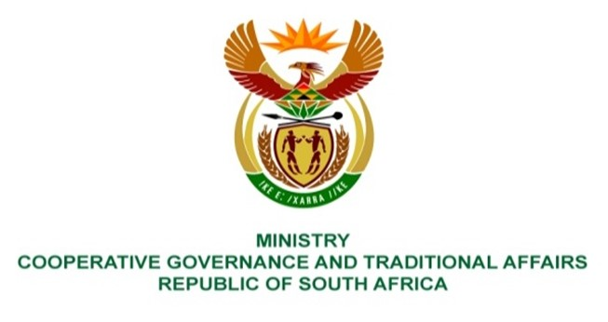

NATIONAL ASSEMBLY
QUESTIONS FOR WRITTEN REPLY

DATE OF PUBLICATION: 19 May 2023

1911. Ms R N Komane (EFF) to ask the Minister of Cooperative Governance and Traditional Affairs:
Whether she and/or her department are responsible for the flushing toilets installed in rural areas; if not, what is the position in this regard; if so, (a) what measures has her department put in place to maintain the flushing toilets installed in rural areas as most of the toilets are not working due to either a lack of water and/or the sewer system not properly working, which in the end causes leaks and (b) who is to be held responsible for the conditions of the toilets? NW2165E

REPLY:

No, neither the Minister of Cooperative Governance and Traditional Affairs nor the Department of Cooperative Governance (DCOG) is responsible for the flushing toilets installed in rural areas. The provision of sanitation to households in general, and of flushing toilets in rural areas, as well as operational and maintenance of the sewer systems is the responsibility of the municipalities that have been designated Water Services Authorities (WSAs) in terms of the Water Services Act 108 of 1997.

DCOG provides support and strengthens the capacity of WSAs in accordance with section 154 of Constitution by deploying technical support through the Municipal Infrastructure Support Agent (MISA). When a WSA fails to fulfil its obligations in terms of the Constitution, and the provincial executive has also failed to intervene, the national executive may intervene in terms of section 139 (7) of the Constitution.

- and (b) Not applicable.
End

