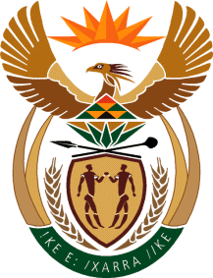

MINISTRY OF TOURISM
REPUBLIC OF SOUTH AFRICA

Private Bag X424, Pretoria, 0001, South Africa. Tel. (+27 12) 444 6780, Fax (+27 12) 444 7027
Private Bag X9154, Cape Town, 8000, South Africa. Tel. (+27 21) 469 5800, Fax: (+27 21) 465 3216

NATIONAL ASSEMBLY:

QUESTION FOR WRITTEN REPLY:
Question Number: 1911
Date of Publication: 21 August2020
NA IQP Number: 32
Date of reply: 05 September 2020

Mr M S F de Freitas (DA) to ask the Minister of Tourism:
With reference to her reply to question 423 on 30 April 2020, what is the set deadline for her to receive the final report on the SA Tourism Board Assessment Reviews? NW2426E

REPLY:

The South African Board Assessment Reviews were received on 13 May 2020.

