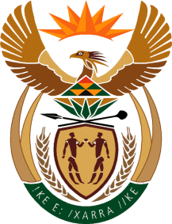

MINISTRY OF TOURISM

REPUBLIC OF SOUTH AFRICA

Private Bag X424, Pretoria, 0001, South Africa. Tel. (+27 12) 444 6780, Fax (+27 12) 444 7027

Private Bag X9154, Cape Town, 8000, South Africa. Tel. (+27 21) 469 5800, Fax: (+27 21) 465 3216

Ref: TM2/1/1/0

NATIONAL ASSEMBLY:

QUESTION FOR WRITTEN REPLY:
Question Number: 1911
Date of Publication: 16 September 2016
NA IQP Number: 28
Date of reply:

Mr S Mokgalapa (DA) to ask the Minister of Tourism:

(a) What are the causes for the delays in the transfer of R2,9 million from his department to SA Tourism and (b) how often did SA Tourism not receive funds allocated by his department as per the agreed time frames? NW2222E

Reply:

- There was no delay in the transfer of funds to South African Tourism. The total marketing allocation as appropriated was transferred in April 2016 upon National Treasury’s approval, to allow for management of potential currency losses.

(b) Not applicable. The department transfers the contribution to South African Tourism quarterly in advance.

