National Assembly

Question No 1910

Mr N Singh (IFP) to ask the Minister of Transport

Whether his department has conducted any assessments of the floods damage and work needed to restore and improve the road infrastructure along the N2 South Coast between Stanger and Scottburgh; if not, what is the position in this regard; if so, (a) how have the assessments been done, (b) what (i) remedial action is being considered and/or implemented and (ii) are the time frames and (c) what tenders have been called for the repair of the specified section of the road? NW2247E

REPLY

- The assessments have been undertaken by teams of engineering specialists and project managers within SANRAL, complemented by specialist consulting engineering firms.

- (i) and (ii) as per table below:

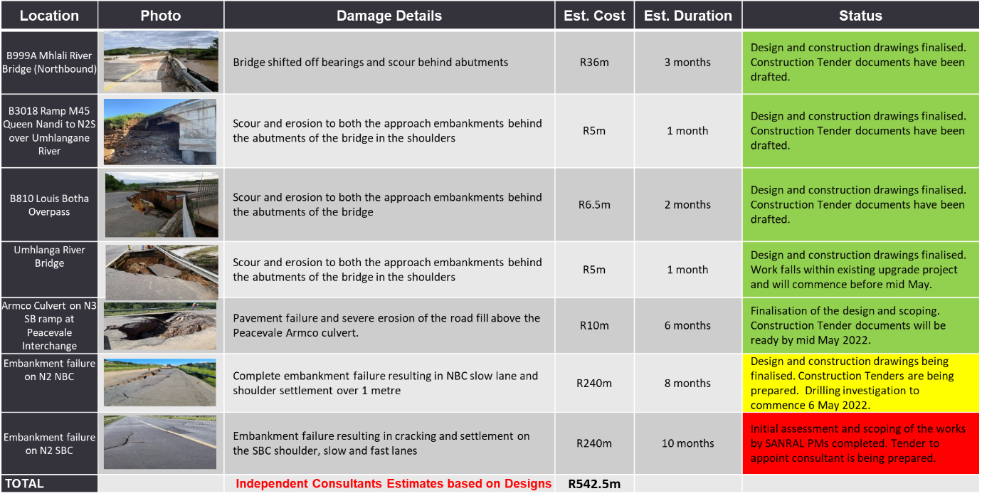

- Procurement documents are in the process of being finalised where applicable for the sites indicated above. In the interim, holding actions are being undertaken by routine road maintenance contractors.

