National of Assembly

Question No: 1910

1910. Mr C H HHunsinger (DA) to ask the Minister of Transport:
How much income has the economy lost due to truck protests and arson attacks in the past three financial years? NW2425E
REPLY

- Impact of strikes by truck drivers and arson attacks on the economy (income lost)

South Africa trades with the rest of Africa and is largely through road transportation. The unrests within the road freight transport are negatively affecting the movements of goods and services in the country and the entire continent.

The embarking of strikes by South African truck drivers can be traced back to at least 2017. On 1 March 2017, the disgruntled truck drivers from coal sector organised a march to Union Buildings, which was against the contracting of Independent Power Producers (IPPs) by Eskom. They thought the move by Eskom will affect coal transportation industry and many people would lose their jobs.

  - Costs and Damages

The tensions between South African and foreign truck drivers have been ongoing for few years now. Most strikes that have happened in the country are against the employment of foreign truck drivers because, South Africans are concerned of the dominance of foreign nationals in not only the trucking industry, but also in other sectors given the high unemployment rate in the country.

The drivers from various truck unions (including All Truck Drivers Foundation) are calling for truck owners to refrain from employing foreign truck drivers in order to preserve jobs for South African. The All Truck Drivers Foundations (ATDF) argues that foreign drivers are being preferred when it comes to employment. It is unfortunate that most of the strikes turned violent.

These truck protests have a negative impact on trade in the country. The blockade of roads affects movements of other road users within the country. The motorists had to use alternative routes or be delayed on their business activities. As a result, two freight trucks were attacked and torched, which were carrying products bound for a grocery store; that led to the closure of the N1 highway near Paarl in Western Cape.

Some protests by truck drivers are over a wage dispute, which resulted in burning of trucks. This happed in April 2018 in Mooi River toll plaza, Kwa Zulu Natal.
According to Road Freight Association, the costs of attacks on trucks is about R1.2 billion with 1200 vehicles and cargo destroyed.

  - Income contribution

According to Land Transport Survey, which was released by Statistics South Africa in 2018, 77.3% of freight categorised as land freight in South Africa is hauled on its roads, accounting for 73.8% of total land freight income. Figure 1 indicates year-on-year percentage in freight transportation (income at current prices) from Land Transport Survey (P7162), monthly statistical releases.

Figure 1: Percentage Change of Income from Road Freight Transportation
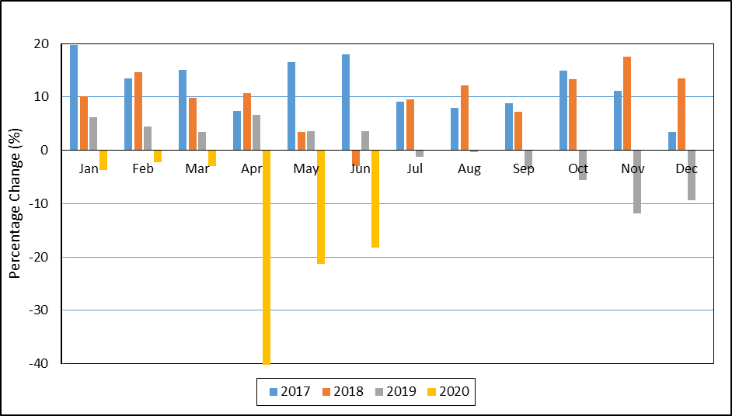
Data Source: Land Transport Survey (StatsSA)

Level of income in the road freight has been increasing in 2017 and 2018. According to StatsSA’s Land Transport Survey, income from road freight transportation has increased by 11.9% and 9.8% in 2017 and 2018, respectively. However, there was a decline of 0.7% in 2019.

As illustrated in Figure 1, income from road freight transportation recorded an increase in all months of 2017 despite a march organised by truck drivers to Union Buildings in Pretoria.

In 2018, there was an increase in income in all months, except only decrease of 3% that occurred in June. The decrease of income in June 2018 was due to truck drivers’ protest regarding a wage dispute and demanding that foreigners should not be permitted to drive trucks in the country.

In 2019, income from road freight transportation decreased from July until the end of the year. This was mainly due to continuous tensions between local and foreign truck drivers. The local drivers accused foreigners of stealing their jobs, while International Cross-Border Traders Association (ICTA) also threatened to prevent SA registered trucks and buses to travel outside borders of SA if the industrial action went ahead.

The effect of COVID-19 and lockdown was experienced in the road freight transport in 2020. The road freight industry recorded a highest drop in income of 40.2%, 21.3% and 18.3% in April, May and June, respectively, which are the highest decline over the past three years. The recent tension occurred in June 2020 and culminated in violence, with trucks being set alight in KwaZulu-Natal, Mpumalanga and Western Cape.

