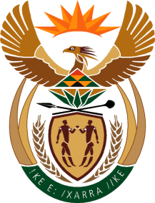

MINISTRY OF TOURISM
REPUBLIC OF SOUTH AFRICA

Private Bag X424, Pretoria, 0001, South Africa. Tel. (+27 12) 444 6780, Fax (+27 12) 444 7027
Private Bag X9154, Cape Town, 8000, South Africa. Tel. (+27 21) 469 5800, Fax: (+27 21) 465 3216

Ref: TM2/1/1/0

NATIONAL ASSEMBLY:

QUESTION FOR WRITTEN REPLY:
Question Number: 1910
Date of Publication: 16 September 2016
NA IQP Number: 28
Date of reply:

Mr S Mokgalapa (DA) to ask the Minister of Tourism:

How has his department allocated the additional R10,7 million received from the tourist levies collected by Tourism Marketing of South Africa? NW2221E

Reply:
The additional funding of R10,7 million is being used for marketing activities through the Tourism Business Council of SA (TBCSA)/ Tourism Marketing South Africa (TOMSA) and the SA Tourism Collaborative Fund. Four core markets, namely Germany, United States of America, United Kingdom and China have been selected for Joint Marketing Agreements to boost tourist arrivals and tourism revenue into South Africa.

