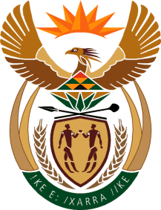

MINISTRY OF TOURISM
REPUBLIC OF SOUTH AFRICA

Private Bag X424, Pretoria, 0001, South Africa. Tel. (+27 12) 444 6780, Fax (+27 12) 444 7027
Private Bag X9154, Cape Town, 8000, South Africa. Tel. (+27 21) 469 5800, Fax: (+27 21) 465 3216

Ref: TM2/1/1/0

NATIONAL ASSEMBLY:
QUESTION FOR WRITTEN REPLY:
Question Number: 1908
Date of Publication: 16 September 2016
NA IQP Number: 28
Date of reply: 30 September 2016 ?

Mr T W Mhlongo (DA) to ask the Minister of Tourism:

Whether he has found that the outcome of the United Kingdom referendum to exit the European Union has had any effects on the number of tourists visiting South Africa from the specified country; if not, why not; if so, what are the relevant details? NW2219E

Reply:
I have not found that the outcome of the UK referendum has had any effect on tourists’ arrival to South Africa. It is important to note that it would be premature to make any statements on the impact on tourism. Uncertainty around developments in some areas could in the short and medium-term impact on arrivals to South Africa from the UK. It is probable that in the short-term, personal spending will be conservative in anticipation of negative impacts, and that long-haul travel and spending on non-essentials may be conservative.

In the context of arrivals to South Africa, it must be noted that
- June to August are low season months for travel to SA (peak travel months are December-February) and any impact would not be immediately visible.
- The majority of leisure travellers decide on a holiday to SA at least three months before travel. Impact on arrival numbers will only be noted from October 2016 onwards.

