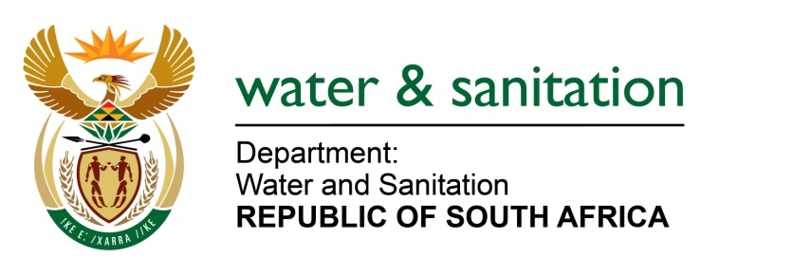

NATIONAL ASSEMBLY

FOR WRITTEN REPLY

QUESTION NO 1904

DATE OF PUBLICATION IN INTERNAL QUESTION PAPER: 19 MAY 2023
(INTERNAL QUESTION PAPER NO. 18)
1904. Mr K Ceza (EFF) to ask the Minister of Water and Sanitation:
What measures has his department taken to intervene in the (a) Emalahleni Local Municipality, (b) Emakhazeni Local Municipality, (c) Dr J S Moroka Local Municipality, (d) Victor Khanye Local Municipality, (e) Lekwa Local Municipality, (f) Dipaliseng Local Municipality and (g) Steve Tshwete Local Municipality where water has been contaminated and is affecting the health of residents? NW2158E
---00O00---
MINISTER OF WATER AND SANITATION
The Department of Water and Sanitation (DWS) currently has numerous interventions being implemented across the various municipalities within the Mpumalanga Province. The table below provides information in interventions for the municipalities including Emalahleni Local Municipality, Emakhazeni Local Municipality, Dr J S Moroka Local Municipality, Victor Khanye Local Municipality, Lekwa Local Municipality, Dipaliseng Local Municipality, and the Steve Tshwete Local Municipality.
 | Local Municipality | Intervention | Objective | Anticipated date of completion
a | Emalahleni | DWS has Infrastructure Development Management (IDM) relating to Water Conservation Demand Management (WCDM) | Water Conservation and Demand Management | Ongoing
b | Emakhazeni | DWS provided financial assistance for the construction of sewer outfall, upgrading and refurbishment of Madala Sewer Main Line and Emgwenya WasteWater Treatment Works | To improve the quality of treated effluent discharged into the water resource (Inkomati catchment for Mngwenya & Olifants catchment for Belfast) and prevent the associated environmental pollution. | Two projects are expected to be completed on 31 July 2023
c | Dr J S Moroka | DWS has Infrastructure Development Management (IDM) relates to Water Conservation Demand Management (WCDM) not water quality | Water Conservation and Demand Management | Ongoing
d | Victor Khanye | Upgrading of the Delmas Wastewater Treatment Works from 4.5ML/d to 12ML/d | To improve the quality of treated effluent discharged into the water resource (Olifants catchment) to prevent the associated environmental pollution | 13 May 2024
e | Lekwa | Various projects relating to management of effluent in areas including Rooikopen, Sakhile and Standerton town | Eliminating sewer spillages within households.  Project entails replacement of sewer reticulation network, refurbishment / upgrading of pump stations, unblocking of sewer lines and repairs of water reticulation including water conservation and demand management. | June 2024
f | Dipaliseng | Upgrading of Balfour WTW’s from 6.5ML/d to 19.5ML/d  Construction of bulk pipeline from Fortuna to Grooitvlei including storage facilities | To supplement water supply to Balfour, Siyathemba, Grooitvlei / Nthorwane and Greylingstad. | Upgrading of WTW’s is due for completion in August 2023.  Bulk pipeline due to be completed in March 2024.
g | Steve Tshwete | Assisting the municipality to refurbish and upgrade the Vaalbank Water Treatment Works which supplies water to Middelburg and Mhluzi areas | To improve process performance and reduction of sulphate to ensure acceptable drinking water quality. | December 2023

---00O00---

