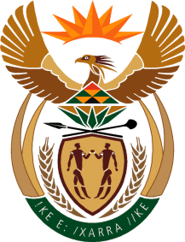

MINISTRY OF TOURISM
REPUBLIC OF SOUTH AFRICA

Private Bag X424, Pretoria, 0001, South Africa. Tel. (+27 12) 444 6780, Fax (+27 12) 444 7027
Private Bag X9154, Cape Town, 8000, South Africa. Tel. (+27 21) 469 5800, Fax: (+27 21) 465 3216

Ref: TM2/1/1/0

NATIONAL ASSEMBLY:

QUESTION FOR WRITTEN REPLY:
Question Number: 1904
Date of Publication: 16 September 2016
NA IQP Number: 28
Date of reply:

Mr T R Majola (DA) to ask the Minister of Tourism:

Why has the SA National Convention Bureau not tabled its quarterly breakdown of the 138 meetings scheduled for the 2016-17 financial year, as committed to in the presentation made by SA Tourism to the Portfolio Committee on Tourism on 8 April 2016? NW2215E

Reply
The SA National Convention Bureau provided a report to the Portfolio Committee as Annexure A1 of the SA Tourism Quarter 1 presentation to the Portfolio Committee, for the meeting of 2 September 2016. The document was distributed on 29 August 2016 to the committee secretariat.

