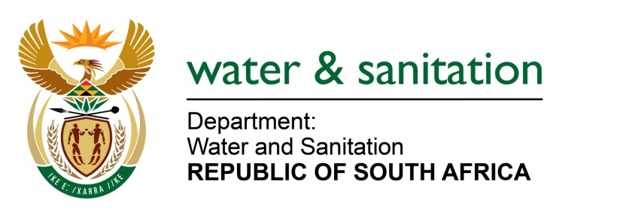

NATIONAL ASSEMBLY

FOR WRITTEN REPLY

QUESTION NO 1900

DATE OF PUBLICATION IN INTERNAL QUESTION PAPER: 23 JUNE 2017
(INTERNAL QUESTION PAPER NO. 23)
1900. Ms M S Khawula (EFF) to ask the Minister of Water and Sanitation:
Whether (a) her department and (b) each entity reporting to her appointed transaction advisors for tenders in the period 1 January 2012 to 31 December 2016; if so, (i) who were the transaction advisors that were appointed for the tenders, (ii) for which tenders were they appointed, (iii) what was the pricing for the tenders in question and (iv) what amount were the transaction advisors paid? NW2112E
---00O00---
REPLY:
No transaction advisors for tenders were appointed by my Department or each entity reporting to me for the period 01 January 2012 to 31 December 2016.
---00O00---

