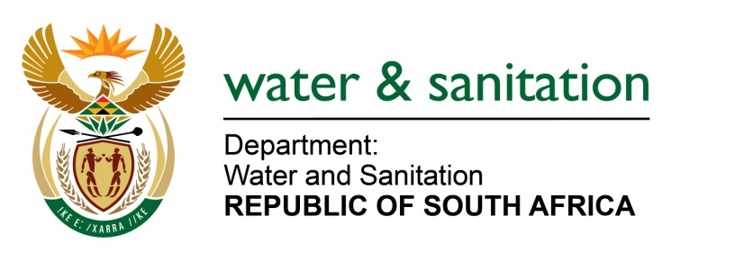

NATIONAL ASSEMBLY

FOR WRITTEN REPLY

QUESTION NO 190

DATE OF PUBLICATION IN INTERNAL QUESTION PAPER: 11 FEBRUARY 2016
(INTERNAL QUESTION PAPER NO. 1)

190. Ms N W A Mazzone (DA) to ask the Minister of Water and Sanitation:
(1) Whether, following the completion of the R3 billion De Hoop Dam in Limpopo, the residents of the district municipalities of (a) Sekhukhune, (b) Waterberg and (c) Capricorn are being provided with piped water from the specified dam; if not, (i) why not and (ii) how many villages surrounding the specified dam are not being provided with water from the specified dam; if so, what are the relevant details;
(2) (a) what is the current status of the project to supply residents in the vicinity of the specified dam with drinking water from the specified dam and (b) when will the project be completed? NW190E
---00O00---
REPLY:

(1)(a) Sekhukhune: has not yet benefited from De Hoop Dam. The Pump station and water treatment plant at the Steel Bridge as well as the main pipeline that will provide water to Jane Furse is the responsibility of the Sekhukhune District Municipality.
(1)(b) Waterberg: has not yet benefited from De Hoop Dam. Communities in the Waterberg area will only be able to receive water from the system once the Phase 2B pipeline and the extension of the pipeline from Pruissen to Sekuruwe has been installed. This pipeline is not yet constructed. This pipeline is largely commercial, and is highly contested by the Mining House. Discussions with the Mining House are now at a high level.

(1)(c) Capricorn: The communities in the Capricorn district municipal area are currently receiving water from the Olifantspoort water treatment plant which is fed from the Flag Boshielo Dam. As soon as Phase 2D, 2E and 2F are completed, water will be delivered at the Olifantspoort treatment plant from the De Hoop Dam. The current shortages of water in that area will then also be augmented through these pipelines. These phases have not yet been constructed. The project is currently at design phase.
(2)(a) Phase 2C (pipeline from De Hoop Dam to Steelpoort) is under construction and is nearing completion. Phase 2B a pipeline between Flag Boshielo and Pruissen must still be constructed to provide water to platinum mines in the Pruissen area. In order for Phase 2C infrastructure to integrate the Olifants and Steelpoort system with the remaining sub-phases, there is a need to construct the remaining sub-phases (Phase 2D, E and F).
(2)(b) Although Phase 2C pipeline for bulk raw water is projected to be finished by July 2016, for the water to reach the people other works need to be completed by the municipality. The Department will commence with the construction of Phase 2 (bulk distribution system, phase 2D, E and F) in the 2016/17 financial year. The Department is in the process of engaging the municipalities involved in order to assist with the acceleration of reticulation so that the process can run parallel with bulk distribution. It must be noted that the pipelines will not be able to supply water to the villages if the three Water Treatment Plants in the area are not refurbished/ rehabilitated.
---00O00---

