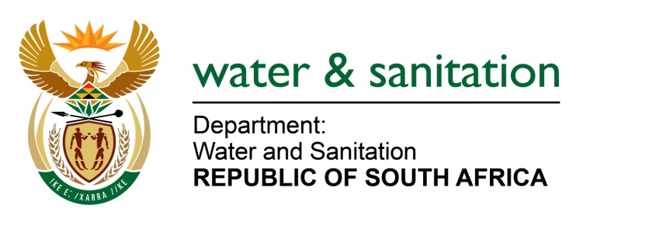

MINISTER OF WATER AND SANITATION

FOR WRITTEN REPLY

QUESTION NO 19

DATE OF PUBLICATION IN INTERNAL QUESTION PAPER: 10 FEBRUARY 2022
(INTERNAL QUESTION PAPER NO. 1)

19. Ms S A Buthelezi (IFP) to ask the Minister of Water and Sanitation:

(1) In light of the water shortages experienced by the residents in the eThekwini Metropolitan Municipality area and surrounding areas, specifically in Umlazi, where residents at times go hours and even days without running water and experience periodical cut-offs, what interventions has his department made in this regard, including (a) mechanisms, (b) processes and (c) procedures that have been implemented to avoid future water cuts;

---00O00---

Minister of Water and Sanitation
- The municipality rations water supply to avoid total collapse of the water supply infrastructure. The water rationing is done on a daily basis at night-time where demand for water is less allowing the infrastructure to build up storage. This is done from 20H00 to 03H00.

The Department of Water and Sanitation instructed eThekwini Metro as the WSA within its jurisdiction to undertake an investigation on the ongoing water supply interruptions within and surrounding Umlazi areas. The report indicated short, medium, and long terms solutions to mitigate the water supply challenges in the Umlazi areas.
The table below shows the short, medium, and long terms solutions that eThekwini Metro has initiated and planned to undertake to stabilize the Umlazi water system:
Item | Intervention | Description | Budget Required | Funding Source | Financial Year
1. | Short Term | Dedicated day to day operation and maintenance of Umlazi water supply system | R560 000 per month (outsourced excluding internal costs) | Internal O&M Budget | 2021/2022
2. | Medium Term | Optimized maintenance of the Umlazi water supply system | R560 000 per month (outsourced excluding internal costs) | Internal O&M Budget | 2021/2022
3. | Long Term | Replacement and Upgrade of the Umlazi water supply system | R2 billion (including bulk and distribution networks) | Not funded yet | N/A

Water supply into Umlazi system comes from Durban Heights Water Treatment Works (DHWTW) located in Reservoir Hills through the twin southern aqueduct lines, 1200mm steel and a 950mm diameter pipes. This aqueduct supplies Shallcross, Chatsworth, Northdene, Queensburgh, St Wendolins, Washington Heights, Welbedatch and ultimately Umlazi (including Nsimbini, Folweni and Golokodo).
The condition of the 950mm diameter pipe has deteriorated over the past four years which caused frequent major leaks that required major repairs resulting to a decision to isolate all sections of this pipe. The impact of the pipe isolation resulted in reduced system input volume to all downstream areas (Chatsworth, Shallcross, St Wendolins, Nagina, Northdene, Queensburgh, Welbedatch, Umlazi, Folweni, Nsimbini and Golokodo). This affected most the critical points (furthest and highest points), Umlazi 2 which supplies C, F, G, H, N & W Sections and ultimately Nsimbini, Folweni and Golokodo.

(a-c) The municipality, together with its water service provider (Umgeni Water) is in the process of refurbishing and upgrading bulk infrastructure which includes upgrade and replacement of bulk pipelines. The refurbishment of Reservoir 3 began in November 2019 and is scheduled to be completed by August 2022.
---00O00---

