NATIONAL ASSEMBLY

WRITTEN REPLY

PARLIAMENTARY QUESTION 1896

DATE OF PUBLICATION: 15 JUNE 2018

Mr J A Esterhuizen (IFP) to ask the Minister of Economic Development:

What (a) is the rationale behind Government’s imposition of import duties on imported steel and (b) has he found to be the impact of the import duties on the amount of steel that was imported in the (i) 2016-17 and (ii) 2017-18 financial years?
NW1896E
REPLY:

- The rationale behind Government’s imposition of import duties on imported steel was to protect local steel manufacturing capacity from the surge of imports resulting from the global oversupply of steel.

South Africa is the only African country with this manufacturing capability and the steel industry is strategic to the country, given its linkages with other sectors of the economy.

The extremely low-priced imports of primary steel products originating mainly from Asia were harming local steel producers, as demonstrated by declining market shares, reduction in sales and production volumes, low capacity utilisation, declining employment and investments. The local producers were in a deteriorating competitive position in part attributable to escalating costs. Evraz Highveld Steel and Vanadium Ltd, the sole domestic manufacturer of heavy structural steel, ceased manufacturing and filed for business rescue. When industry applied to the State for assistance, Government considered the application and approved a request for increased import duties.

In the case of the largest steel producer, government placed a reciprocal commitment on the company to increase its level of capital spending in order to improve its overall competitiveness; and the company agreed to save jobs that would otherwise have been lost as a result of retrenchments.

- The overall impact of duties on the amount of steel imported into the domestic industry has been positive between the 2016/17 and 2017/18 financial years. This is evident from the decline in import volumes of flat and long steel products over the periods mentioned (see below table). However, imports of certain coated flat steel (galvanised) products are showing an increasing trend. This may be due to the importation of niche products and ultra-thin galvanised flat products which are not locally manufactured or they may reflect in part a circumvention of duties by importers. ITAC has been requested to monitor this and to take appropriate steps where warranted.

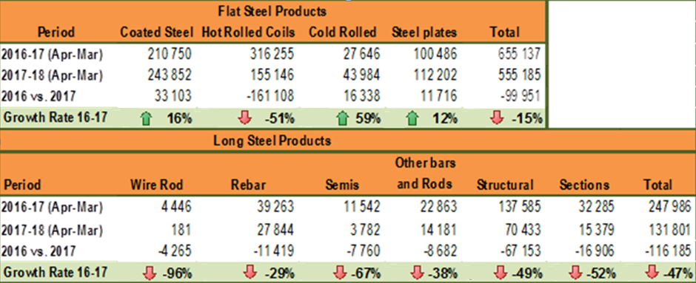

-END-

