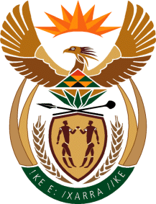

MINISTER IN THE PRESIDENCY: REPUBLIC OF SOUTH AFRICA
Private Bag X1000, Pretoria, 0001, Union Buildings, Government Avenue, PRETORIA
Tel: (012) 300 5200, Website: www.thepresidency.gov.za

NATIONAL ASSEMBLY
WRITTEN QUESTION FOR WRITTEN REPLY
QUESTION NUMBER: 1892
DATE OF PUBLICATIONS: 20 MAY 2022

1892. Mr I S Seitlholo (DA) to ask the Minister in The Presidency:

Whether, in light of the fact that The Presidency issued proclamation 210 of 2021 to investigate the matter relating to the R103 million in advanced payment to Ayamah Consulting, which was done without following the provisions of the Public Finance Management Act, Act 1 of 1999 (details furnished), the investigation was completed; if not, why not; if so, (a) has the report of the investigation been given to the President and (b) on what date is it envisaged that the report will be made public? NW2228E

REPLY:

It is indeed correct that the President, acting in terms of section 2(1) of the Special Investigating Units and Special Tribunals Act, 1996, referred the matters in respect of the North West Provincial Department of Public Works and Roads (“the Department”) to the Special Investigation Unit (“SIU”) for investigation.

The matters which are investigated by the SIU as contained in proclamation 210 of of 12 March 2021 inculde:

- The procurement of or contracting for works or services by or on behalf of the Department for―

  - Project management for the Transport Infrastructure Directorate of the Department;

  - the rehabilitation of flood damaged road infrastructure in the North West Province; and

  - the installation of perimeter fencing at the Eagle Waters Wildlife Resort.

The investigation by the SIU in the matter is still ongoing. As such, the SIU has not yet submitted a report to the President. As per the normal practice, upon receipt of the final report from the SIU, the Presidency will process the report and ensure that the report is also given to all relevant stake holders.

Thank You.

