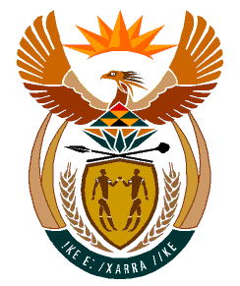

MINISTRY
HUMAN SETTLEMENTS
REPUBLIC OF SOUTH AFRICA

Private Bag X645, Pretoria, 0001. Tel: (012) 421 1309, Fax: (012) 341 8513

Private Bag X9029, Cape Town, 8000. Tel (021) 466 7603, Fax: (021) 466 3610

NATIONAL ASSEMBLY
QUESTION FOR WRITTEN REPLY
QUESTION NUMBER: 189
DATE OF PUBLICATION: 10 FEBRUARY 2022

Mr G R Krumbock (DA) to ask the Minister of Human Settlements:
(a) What number of supplier invoices currently remain unpaid by (i) her department and (ii) each entity reporting to her for more than (aa) 30 days, (bb) 60 days, (cc) 90 days and (dd) 120 days, (b) what is the total amount outstanding in each case and (c) by what date is it envisaged that the outstanding amounts will be settled? NW193E

REPLY:
  - Except for invoices under dispute, the National Department of Human Settlements doesn’t have invoices currently remaining unpaid. In relation to invoices under dispute, which as a result have not been paid for the total of the invoices is 52. The aging is as follows: (aa) 30 days, 2 (bb) 60 days, 1 (cc) 90 days, 1 (dd) 120 days, 48

  - The total amount outstanding in each case is as follows: (aa) R190 129.74 (bb) R 3689.20 (cc) R 69 000.00 (dd) R 64 314 311.37
  - There is currently no envisaged date for settlement as payment will depend on co-operation of the affected creditors and the outcomes of investigations.

