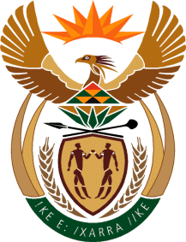

MINISTRY OF TOURISM
REPUBLIC OF SOUTH AFRICA

Private Bag X424, Pretoria, 0001, South Africa. Tel. (+27 12) 444 6780, Fax (+27 12) 444 7027
Private Bag X9154, Cape Town, 8000, South Africa. Tel. (+27 21) 469 5800, Fax: (+27 21) 465 3216

Ref: TM 2/1/1/10

NATIONAL ASSEMBLY:

QUESTION FOR WRITTEN REPLY:
Question Number: 1888
Date of Publication: 1 June 2018
NA IQP Number: 19
Date of reply: 14 June 2018

Ms V Ketabahle (EFF) to ask the Minister of Tourism:
(1) What (a) is the total number of incidents of racism that were reported to the human resources offices in (i) her department and (ii) entities reporting to her in (aa) 2016 and (bb) 2017 and (b) are the details of each incident that took place;
(2) was each incident investigated; if not, why not in each case; if so, what were the outcomes of the investigation in each case? NW2048E

Reply:

- (a)(i) (aa) – (bb) No incidents of racism were reported to the human resources offices of the Department for the period.
(a)(ii) (aa) – (bb) No incidents of racism were reported to the human resources offices of SA Tourism for the period

(b) Not applicable

(2) Not applicable

