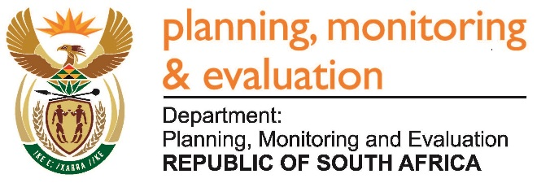 |  | 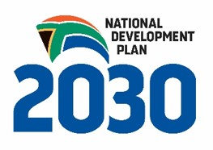
Private Bag X944, PRETORIA, 0001. Union Buildings East Wing, Government Avenue, PRETORIA
Tel: 012 312 0307. www.dpme.gov.za

1882. Ms M O Mokause (EFF) to ask the Minister in The Presidency:

Whether (a) his Office and (b) each entity reporting to him appointed transaction advisors for tenders in the period 1 January 2012 to 31 December 2016; if so, (i) who were the transaction advisors that were appointed for the tenders, (ii) for which tenders were they appointed, (iii) what was the pricing for the tenders in question and (iv) what amount were the transaction advisors paid? NW2094E

REPLY

No.

