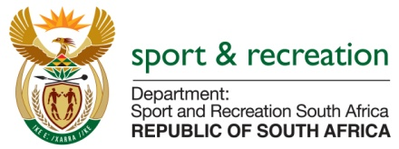

PARLIAMENTARY QUESTION FOR THE MINISTER
QUESTION 1872 (NW2032E) FOR WRITTEN REPLY

QUESTION
Mr. PG Moteka (EFF) to ask the Minister of Sport and Recreation:
- What (a) is the total number of incidents of racism that were reported to the human resources department/office in:
- Her department;
- The entities reporting to her in (aa) 2016 and (bb) 2017
What (b) are the details of each incident that took place;
- Was each incident investigated; if not, why not in each case; if so, what were the outcomes of the investigations in each case? (NW2032E)
REPLY
- The Department of Sport and Recreation has (a) Zero cases of racism incidents reported to its HR Offices….. (i) Her department has zero cases of racism reported and (ii) the entities reporting to her also do not have any such cases that were reported, in the year 2016 and 2017:
No investigation was instituted, as there were not cases of racism reported.

MS T. XASA, MP
MINISTER OF SPORT AND RECREATION SA

