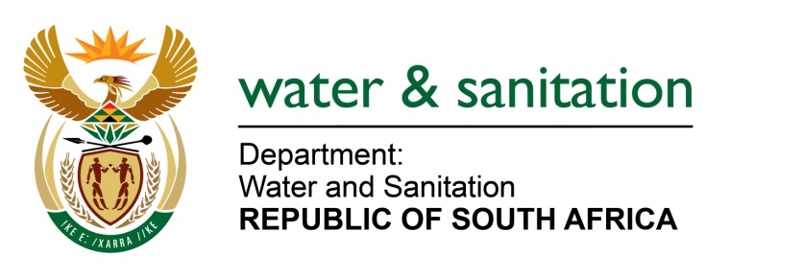

NATIONAL ASSEMBLY

FOR WRITTEN REPLY

QUESTION NO 187

DATE OF PUBLICATION IN INTERNAL QUESTION PAPER: 11 FEBRUARY 2016
(INTERNAL QUESTION PAPER NO. 1)

187. Mr C D Matsepe (DA) to ask the Minister of Water and Sanitation:
(1) What is the total cost of the construction of a pipeline from the Gariep Dam to the KnellpoortDam;
(2) Whether the entire cost of construction is currently funded; if not, how will the pipeline be financed; if so, what are the (a) funding sources and (b) amounts;
(3) What is the estimated (a) start and (b) completion date of the pipeline? NW187E
---00O00---
REPLY:

(1) Current capital cost estimate of the project to augment Mangaung and surrounding areas' water supply from Gariep Dam is in excess of R 7 billion.
(2) A Feasibility study will have to be done to confirm the preferred option to obtain water from the Gariep Dam. This is the only part that has been funded as yet and the funding model of the rest of the project will be confirmed as part of the work done during the Feasibility study. Options to be considered will include project finances both on-budget and off-budget..
(3) The fast-tracked implementation programme, consisting of a Feasibility Study, Environmental Impact Assessment (EIA) process, and Design and Construction phases, will take 5.5 years to completion. The Feasibility Study will be finalised over an eighteen (18) months period before design and construction can start. Construction is expected to start during financial year 2018/19 with completion during the 2022/23 financial year.
---00O00---

