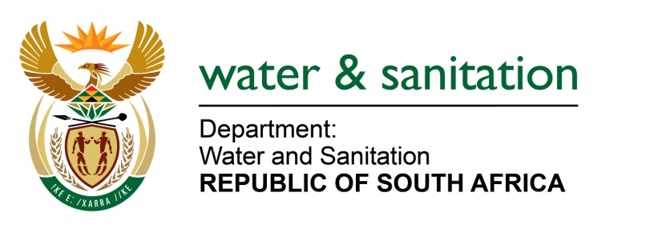

NATIONAL ASSEMBLY

FOR WRITTEN REPLY

QUESTION NO 1869

DATE OF PUBLICATION IN INTERNAL QUESTION PAPER:
(INTERNAL QUESTION PAPER NO. 18) 19 MAY 2023
1869. Mr B N Herron (Good) to ask the Minister of Water and Sanitation:
(1) What (a) does the expanded mandate of the Amatola Water Board entail that warrants a claim of R4 million (details furnished) and (b) successes has the specified board currently achieved through the specified mandate;
(2) what are the details of the (a) actions taken by the specified board to prevent a Day Zero situation and (b) expenditure that was incurred by the board regarding the Nelson Mandela Bay water crisis;
(3) whether his department has instructed an independent auditor and/or monitoring group to oversee the expenditure of the board as the board fees have been approximately 18 % over budget and the initiative has empty coffers; if not, what is the position in this regard; if so, what (a) are the findings of the independent auditor and/or monitoring group and (b) is the protocol of his department in dealing with poor performance and initiatives that are financially draining in the event of their failure? NW2120E
---00O00---

MINISTER OF WATER AND SANITATION

- (a) In May 2022, the Minister issued a directive to Amatola Water in terms of Section 41 (1) and Section 63 (1) of the Water Services Act, to urgently intervene and address water shortages in the Nelson Mandela Bay Metro Municipality (NMBMM) owing to the ongoing drought. The required scope of work for the intervention was to address the following:
- Governance of the water services function within Nelson Mandela Bay Metro Municipality.
- Represent the Minister in terms of Section 73 in fulfilling the Water Services Authority function for the duration of the Section 63 intervention.

- Assisting the municipality with the implementation of the Drought Alleviation Action Plan towards prevention of a “Dry Tap” scenario (especially in the western part of the Metro), through, amongst others: implementing and enforcing water restrictions; implementing a drought awareness communication plan; providing assistance with the water conservation and demand management strategy.

b) The outcomes of the intervention include:
- Accelerating the move of the Impofu barge which stretched available water on the Kromme system from 16 days to 375 days
- Working with the provincial Department of Water and Sanitation (DWS) to ensure restrictions are developed and are reasonable while ensuring that the local dams are given the maximum opportunity to recover
- Furthering work towards transforming the water and sanitation business into a resilient professional and reliable service entity
- An improved drought communication strategy was rolled out in collaboration with NMBMM and Mandela Bay Development Agency
- Facilitating work done by non-governmental Organisations and private sector stakeholders like Coca-Cola Beverages SA on drilling boreholes at municipal owned properties around the municipality
- Eliminating the backlog of leaks in July 2022, and immediately attending to new ones
- Encouraging private sector support, such as the Business Chamber leak repairs and the Strategic Water Partnership Network Memorandum of Understanding
- Creating enabling conditions to accelerate municipal processes
- Supporting the downward trend of water demand
- Supporting water augmentation projects.
- Finalising the capacitation of key positions in the technical team

The Amatola Water Board's approach has been collaborative and initiating a partnership with the NMBM to identify and unblock challenges. The experts have been using their experience and skills to amongst others; advice; share best practices; anticipate challenges and propose common solutions. Close collaboration with the Political Oversight Committee; City officials and organized business has contributed a great deal in moving Day Zero much further from becoming a reality.
2. a) Please refer to the response above in question 1 (b).
b) The total expenditure that was incurred by the Board in relation to the NMBMM water crisis is as follows:
Financial Year 2022 | R305 338. 58
Financial Year 2023 | R282 550. 74
Travel costs | R112 409. 78
Total costs: | R700 409. 10

3. The Department did not instruct any independent auditor and/or monitoring group to oversee the expenditure of Amatola Water Board. Board members are paid based on the DWS Policy on Board Practices and the remuneration of board members of entities reporting to the Minister of Water and Sanitation. According to this policy, Board Members are remunerated on an hourly rate basis for meetings attended. The maximum number of hours that may be remunerated per month for the Chairperson of the Board is 50 hours and Board Members is 40 hours. Any additional hours to be remunerated such as may arise in extraordinary circumstances, should be approved by the Minister prior.

---00O00---

