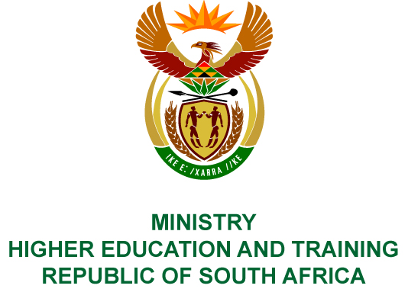
Private Bag X893, Pretoria, 0001, Tel (012) 312 5555, Fax (012) 323 5618
Private Bag X9192, Cape Town, 8000, Tel (021) 469 5150, Fax: (021) 465 7956
Memorandum from the Parliamentary Office
NATIONAL ASSEMBLY
FOR WRITTEN REPLY
QUESTION 1868
DATE OF PUBLICATION OF INTERNAL QUESTION PAPER: 01/06/2018
(INTERNAL QUESTION PAPER NO 19 OF 2018)
Mr S Esau (DA) to ask the Minister of Higher Education and Training:
(1) What (a) is the total number of incidents of racism that were reported to the human resources offices in (i) her department and (ii) entities reporting to her in (aa) 2016 and (bb) 2017 and (b) are the details of each incident that took place;
(2) was each incident investigated; if not, why not in each case; if so, what were the outcomes of the investigation in each case?

NW2028E
REPLY:
- (a) (i) The total number of incidents of racism that were reported to the Human Resource offices of the Department are as follows:
(aa) 2016 - one incident and two allegations; and
(bb) 2017 - one incident.
- In 2016, one incident of racism was reported to the Human Resource offices of the Services Sector Education and Training Authority.
- In 2016, the National Education, Health and Allied Workers Union alleged that there were practices of racism and discrimination within the National Examinations and Assessment Chief Directorate of the Department.
In 2016, an incident involving an official who sent a text message containing racist remarks to a colleague was reported at the Western Technical and Vocation Education and Training (TVET) College.
In 2016, an official allegedly used racist remarks to students at the Mthashana TVET College.
In 2017, an official allegedly sent a letter to the Council of the Ikhala TVET College containing racist remarks.
A subordinate within the Human Resource unit of the Services Sector Education and Training Authority made an allegation of racism against a manager.
- In response to the allegations, the Department in 2017 conducted diversity management workshops. It also recommended that the allegations of racism and discrimination within the National Examination and Assessment Chief Directorate be referred to the Human Rights Commission for an independent investigation.
The incident involving an official who sent a text message allegedly containing racist remarks to a colleague was reported and investigated by the Western TVET College. The investigation was finalised, and the decision to institute a disciplinary hearing was taken wherein the official was found guilty, and the Chairperson issued a sanction of dismissal on 30 May 2016. The official filed a notice to appeal, which was dismissed by the Minister of Higher Education and Training on the advice of the Appeal Committee on 27 October 2016. The official thereafter lodged a dispute with the Education Labour Relations Council (ELRC) for unfair dismissal. The ELRC confirmed the dismissal on 26 April 2017.
The matter involving an official who allegedly used racist remarks toward students in 2016 at Mthashana TVET College, has been investigated and finalised. A decision to institute a disciplinary hearing wherein the official was found guilty, and the Chairperson issued a sanction of dismissal on 18 July 2016. The official filed a notice to appeal, which on review by the Minister of Higher Education and Training, and on the advice of the Appeal Committee, the sanction of dismissal was replaced with a final written warning on 27 October 2016.
The Ikhala TVET College instituted a disciplinary hearing without conducting an investigation. The disciplinary hearing commenced on 26 July 2017, the matter was finalised on 28 February 2018 wherein the official was found guilty, and the Chairperson issued a sanction of dismissal. The official has filed a notice to appeal on 07 March 2018. The outcome of the appeal is pending.
In relation to the Services Sector Education and Training Authority, the matter was investigated, and it was found that the issue of racism could not be substantiated.

