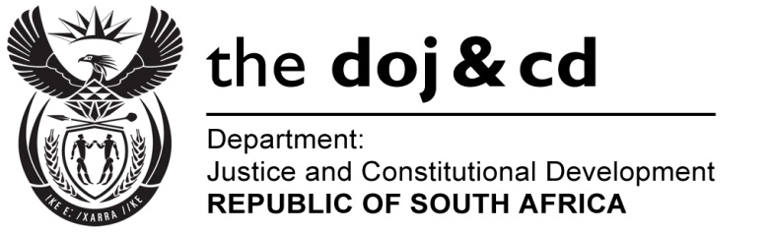
NATIONAL ASSEMBLY
PARLIAMENTARY FOR WRITTEN REPLY
PARLIAMENTARY QUESTION NO: 1866
DATE OF QUESTION PAPER: 09 SEPTEMBER 2016

DATE OF SUBMISSION: 23 SEPTEMBER 2016
The Leader of the Opposition (DA) to ask the Minister of Justice and Correctional Services:
With reference to the Minister of Police’s replies to question (a)(i) 3723 on 2 November 2015 and (ii) 62 on 29 February 2016 and (b) oral question 98 on 26 May 2016, (aa) what is the current status of docket CAS 123/03/2014, which was opened at the Nkandla Police Station regarding eight charges of corruption against the President, Mr Jacob G Zuma, in terms of the Prevention and Combatting of Corrupt Activities Act, Act 12 of 2004, for his complicity in the alleged misappropriation of public funds to upgrade his personal residence at Nkandla, (bb) which unit is the specified docket currently with, (cc) who is or are the investigating officer(s) and (dd) has anyone been questioned in this regard yet?
NW2176E
REPLY: The National Prosecuting Authority is still considering the matter, no decision has been taken whether or not to prosecute any person(s) in relation to the matter.

