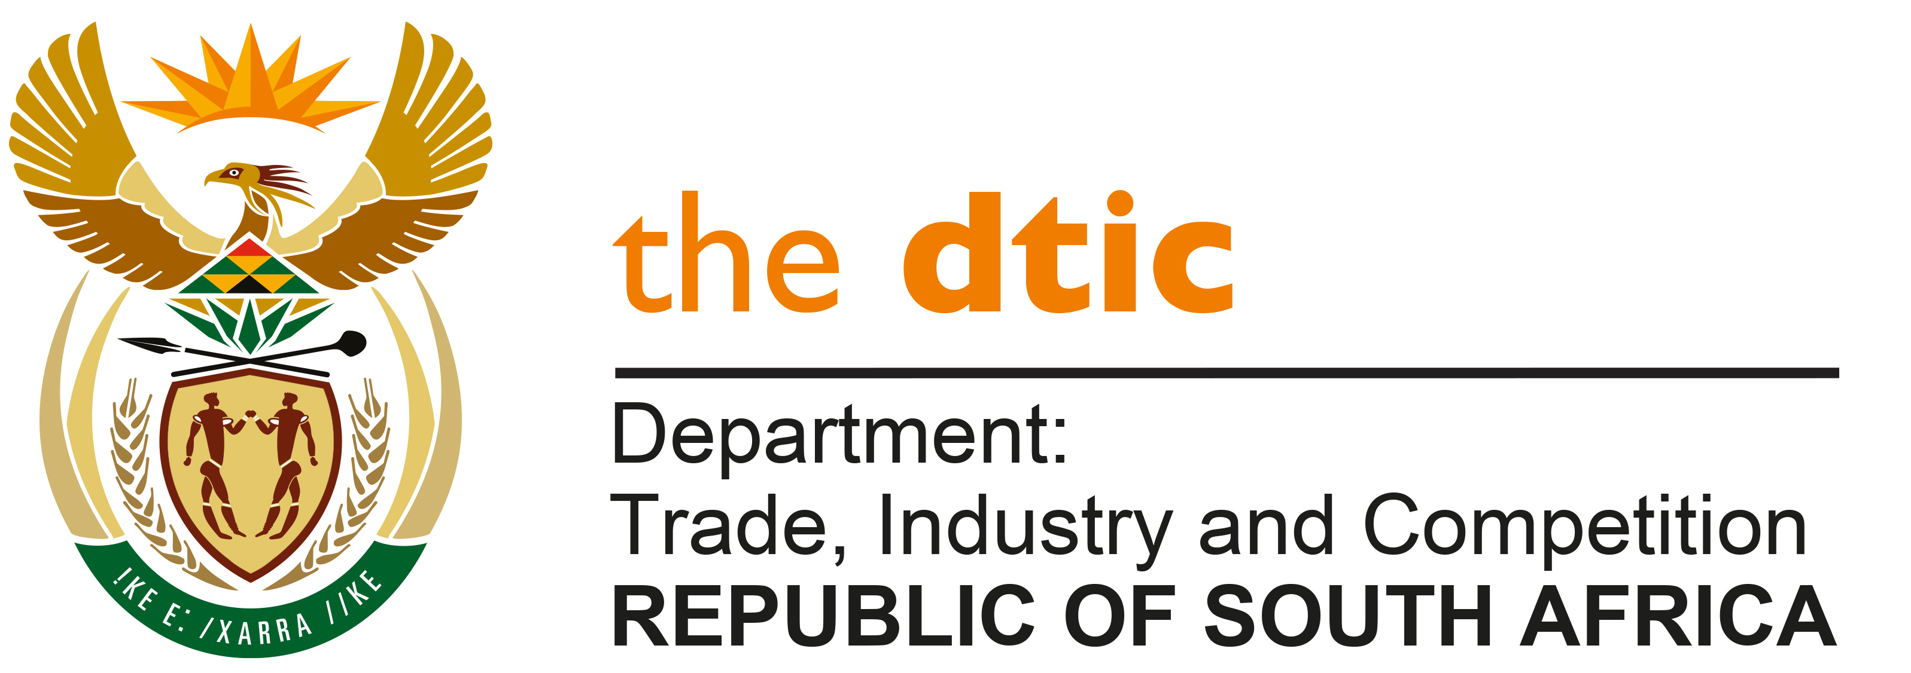

THE NATIONAL ASSEMBLY

QUESTION FOR WRITTEN REPLY

QUESTION NO. 1863

Mr D Bergman (DA) to ask the Minister of Trade, Industry and Competition:
(a) What number of missions does the Republic have around the world and (b) of those missions, what number have trade attachés and/or commissioners? NW2114E

REPLY:

- Announced at the 2023 Budget Vote of the Department of International Relations and Cooperation (DIRCO), South Africa has representation through 116 diplomatic missions in 102 countries.

- In terms of the above DIRCO missions, the dtic has 31 missions allocated for the transfer of officials to serve as Foreign Economic Representatives (FERs), fulfilling the roles associated with trade attachés or commissioners
-END-

