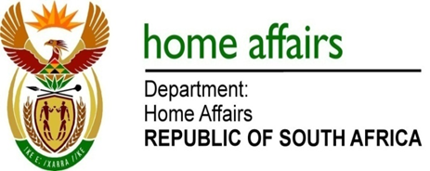

NATIONAL ASSEMBLY

QUESTION FOR WRITTEN REPLY

QUESTION NO. 1862

DATE OF PUBLICATION: FRIDAY, 1 JUNE 2018

INTERNAL QUESTION PAPER 19 OF 2018

1862. Mrs H O Mkhaliphi (EFF) to ask the Minister of Home Affairs:

(1) What (a) is the total number of incidents of racism that were reported to the human resources offices in (i) his department and (ii) entities reporting to him in (aa) 2016 and (bb) 2017 and (b) are the details of each incident that took place;
(2) was each incident investigated; if not, why not in each case; if so, what were the outcomes of the investigation in each case? NW2022E
REPLY:

The Department and entities responded as follows:

- Department of Home Affairs

(1)(a) No incidents of racism were reported to the human resources office in 2016 and 2017.

(1)(b) Not applicable

(2) Not applicable

- Government Printing Works

(1)(a)(aa) 2016 – 1
(1)(a)(bb) 2017 – 1

(1)(b) 2016 – Racist incitement
- – Social media posting

(2) Yes. The employee was dismissed in the 2016 incident and 2017 case employee not found guilty.

- Electoral Commission

(1)(a) No incidents of racism were reported to the human resources office in 2016 and 2017.

(1)(b) Not applicable

(2) Not applicable

