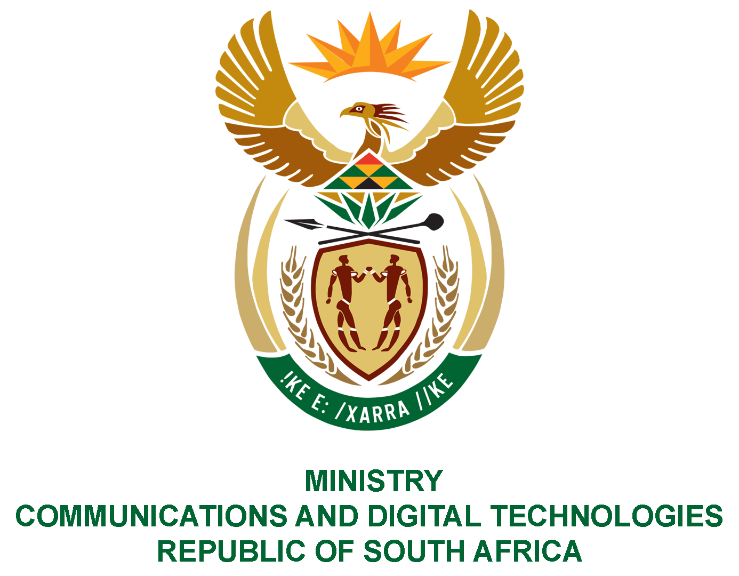
PARLIAMENT OF THE REPUBLIC OF SOUTH AFRICA
NATIONAL ASSEMBLY
WRITTEN REPLY

QUESTION NO: 186
DATE OF PUBLICATION: 11 February 2021
QUESTION PAPER NO: 01
Mr C MacKenzie (DA) to ask the Minister of Communications:
(1) What number of post offices have electronic National Traffic Information System (e-NATIS) vehicle licence machines?
(2) Whether staff are trained on the use of the e-NATIS machines; if not, why not; if so, what (a) number of people are trained in this regard in each branch and (b) is the nature of the training?
NW189E

REPLY:

I have been advised by the SAPO as follows:

1. There are 520 Post Offices nationally across the Provinces, except for the Western Cape (which SAPO does not service currently) that have e-Natis with a current total of 580 machines.

2. Yes, staff are trained on the use of e-Natis machines.
(a) Approximately 2080 staff were trained nationally with a minimum of at least 2 per branch.
(b) Training needs change continually based on specific operational requirements and with the service offerings of the respective branch that are based on specific provincial negotiated agreements. Eastern Cape, Kwa-Zulu Natal and North West have a combination of full service and renewals. SAPO also has a supervisor and teller functions per branch as per e-Natis requirements.

MS. STELLA NDABENI-ABRAHAMS, MP
MINISTER OF COMMUNICATIONS AND DIGITAL TECHNOLOGIES

