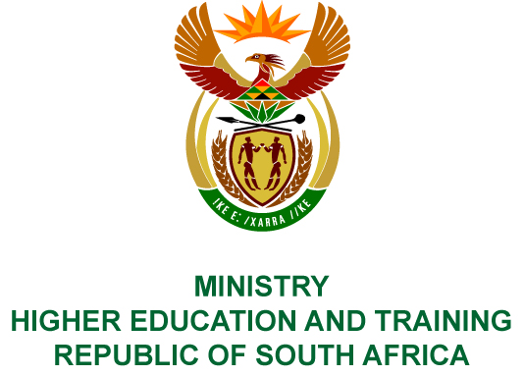
Private Bag X893, Pretoria, 0001, Tel (012) 312 5555, Fax (012) 323 5618
Private Bag X9192, Cape Town, 8000, Tel (021) 469 5150, Fax: (021) 465 7956
Memorandum from the Parliamentary Office
NATIONAL ASSEMBLY
FOR WRITTEN REPLY
QUESTION 186
DATE OF PUBLICATION OF INTERNAL QUESTION PAPER: 08/02/2018

(INTERNAL QUESTION PAPER NO 1 OF 2018)
Mr T E Mulaudzi (EFF) to ask the Minister of Higher Education and Training:
Whether the National Institute for Humanities and Social Sciences hosted and paid for an event at the Grand Central Café in Melrose Arch in 2017; if so, (a) what was the total amount paid, (b) who approved the payment and (c) did the purpose and payment of the event comply with cost cutting measures and regulations of (i) the National Treasury, (ii) her department and (iii) the Auditor-General of South Africa?
NW193E
REPLY:
The National Institute for Humanities and Social Sciences (NIHSS) has provided the following responses to the questions posed.
An event at the Grand Central Café was hosted and paid for in 2017.
- The total amount paid was R6 244.
- The Chief Executive Officer, Professor Sarah Mosoetsa, approved the payment.
- (i) The expenditure complied with the NIHSS’s policies. The NIHSS is neither a Department, nor a constitutional institution, nor a public entity listed in Schedule 2 or 3, and therefore the Public Finance Management Act is not applicable to the NIHSS.
(ii) Spending is managed by the NIHSS in terms of its policies.
(iii) The Auditor-General of South Africa audits the NIHSS in terms of Section 38 of the Higher Education Act and since its inception has received unqualified audit opinions.

COMPILER DETAILS
NAME AND SURNAME: MS PEARL WHITTLE
CONTACT: 012 312 5248
RECOMMENDATION
It is recommended that the Minister signs Parliamentary Question 186.

MR GF QONDE
DIRECTOR–GENERAL: HIGHER EDUCATION AND TRAINING
DATE:

PARLIAMENTARY QUESTION 186 IS APPROVED / NOT APPROVED / AMENDED.
COMMENT/S

PROF HB MKHIZE, MP
MINISTER OF HIGHER EDUCATION AND TRAINING
DATE:

