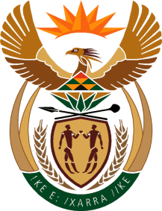

MINISTRY OF TOURISM
REPUBLIC OF SOUTH AFRICA

Private Bag X424, Pretoria, 0001, South Africa. Tel. (+27 12) 444 6780, Fax (+27 12) 444 7027
Private Bag X9154, Cape Town, 8000, South Africa. Tel. (+27 21) 469 5800, Fax: (+27 21) 465 3216

Ref: TM 2/1/1/10

NATIONAL ASSEMBLY:

QUESTION FOR WRITTEN REPLY:
Question Number: 186
Date of Publication: 17 February 2017
NA IQP Number: 2
Date of reply: 3 March 2017

Mr J Vos (DA) to ask the Minister of Tourism:
What is the total number of (a) tourists who visited South Africa in the (i) 2013-14, (ii) 2014-15 and (iii) 2015-16 financial years and (b) passengers that undertook domestic trips in the (i) 2013-14, (ii) 2014-15 and (iii) 2015-16 financial years? NW197E

Reply:

- Total number of tourist who visited South Africa.

- 2013* | - 2014* | - 2015* | - 2016*
8,961,565 | 9,549,236 | 8,903,773 | 10, 044, 163

- Total number of passengers that undertook domestic trips

- 2013 | (ii)2014 | - 2015
12,015,147 | 12,009,209 | 12,431,911

*Tourism statistics for tourist arrivals and tourism revenue are reported on by calendar year in line with global reporting standards. The domestic tourism statistics are also reported on by calendar year.
** Revenue for 2016 still to be determined.

