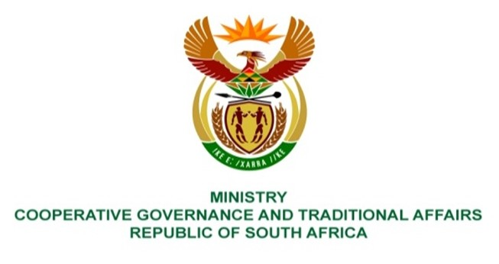

NATIONAL ASSEMBLY
QUESTIONS FOR WRITTEN REPLY

QUESTION NUMBER 1858
DATE OF PUBLICATION: 19 May 2023

1858. Mr W Horn (DA) to ask the Minister of Cooperative Governance and Traditional Affairs:
What are the costs to date to her department related to the national intervention into the administration of the Mangaung Metropolitan Municipality, with reference to national government departments and the specified municipality?
NW2109E
REPLY:
The total costs to date incurred by the Department in relation to the national intervention into the administration of the Mangaung Metropolitan Municipality are R 2, 006 283, 13.
End.

