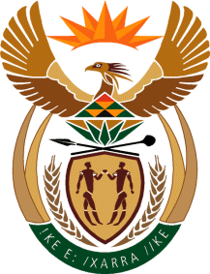

MINISTRY OF TOURISM
REPUBLIC OF SOUTH AFRICA

Private Bag X424, Pretoria, 0001, South Africa. Tel. (+27 12) 444 6780, Fax (+27 12) 444 7027
Private Bag X9154, Cape Town, 8000, South Africa. Tel. (+27 21) 469 5800, Fax: (+27 21) 465 3216

NATIONAL ASSEMBLY:

QUESTION FOR WRITTEN REPLY:
Question Number: 1855
Date of Publication: 20 August 2021
NA IQP Number: 17
Date of reply: 22 October 2021

Ms H S Winkler (DA) to ask the Minister of Tourism:
(a) Whether her department has engaged with the Department of Water and Sanitation to address the issues of water quality and its potentially detrimental effect on tourism, such as the Blue Flag Status of Durban’s Golden Mile Beaches, Durban Harbour’s Wilson’s Wharf and sporting events on the Duzi River; if not, why not; if so, what outcomes were achieved?
NW2083E

REPLY:

The Department has not engaged with the Department of Water and Sanitation (DWS) on this matter. The management of fresh water resources and associated infrastructure is the competency of the DWS, relevant Water Boards as well as relevant municipalities. Furthermore, beaches are the responsibility of relevant local government while marine and coastal management resides with the Department of Fisheries, Forestry and the Environment. It is therefore suggested that the Honourable member refers the question to the relevant authority.

