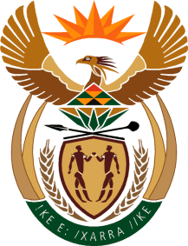

MINISTRY OF TOURISM
REPUBLIC OF SOUTH AFRICA

Private Bag X424, Pretoria, 0001, South Africa. Tel. (+27 12) 444 6780, Fax (+27 12) 444 7027
Private Bag X9154, Cape Town, 8000, South Africa. Tel. (+27 21) 469 5800, Fax: (+27 21) 465 3216

NATIONAL ASSEMBLY:

QUESTION FOR WRITTEN REPLY:
Question Number: 1853
Date of Publication: 20 August 2021
NA IQP Number: 17
Date of reply: 22 October 2021

Ms H S Winkler (DA) to ask the Minister of Tourism:
(a) Whether her department has engaged any further with the Government and stakeholders on the implementation of the Health Passport Worldwide; if not, why not; if so, what outcomes have been achieved? NW2081E

REPLY:

- Yes
- Health Certificate or Passport implementation modalities is a matter that is currently being discussed within government and amongst social partners and relevant authorities shall pronounce in due course.

