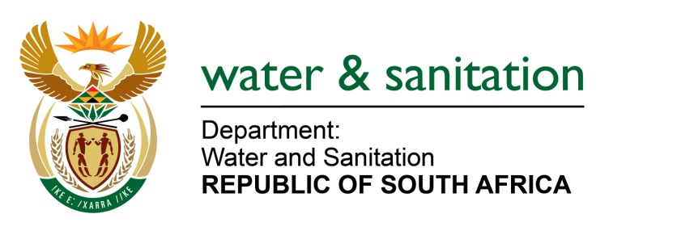

NATIONAL ASSEMBLY

FOR WRITTEN REPLY

QUESTION NO 1852

DATE OF PUBLICATION IN INTERNAL QUESTION PAPER: 19 MAY 2023
(INTERNAL QUESTION PAPER NO. 18)
1852. Mr D W Bryant (DA) to ask the Minister of Water and Sanitation:
(1) What (a) is the relevant financial legislation on which the conducting of the audits for the authorized package plants from 2009 to 2023 relied and (b) are the relevant legal obligations, set out in the specified legislation, on which his department did not rely to ensure that audits were conducted.
(2) (a) what is the total number of licensed wastewater treatment plants in accordance to the National Water Act, Act 36 of 1998, in (i) each province and (ii) the Republic, (b) of those licensed wastewater treatment plants, what percentage was (i) inspected and (ii) audited correctly in each year since 2009 until the latest date of which information is available in 2023, (c) how does his department assess the environmental damage that has resulted from non-compliance and (d) what actions have been taken in cases where wastewater treatment plants were found to be noncompliant with their licensing conditions?
NW2103E
---00O00---
MINISTER OF WATER AND SANITATION
- (a) Compliance monitoring audits are non-financial performance audits conducted to determine conformity by municipalities with the National Water Act, Act 36 of 1998. There is no direct financial legislation applicable.
(b) There were no relevant financial legal obligations involved in conducting compliance audits.

(2) (a) (i) and (ii)
Province | License | Permit | General authorisation | Exemption | Total
Western Cape | 33 | 11 | 37 | 3 | 84
Limpopo | 21 | 0 | 11 | 0 | 32
North-West | 20 | 1 | 1 | 8 | 30
Mpumalanga | 25 | 1 | 6 | 6 | 38
Gauteng | 44 | 0 | 1 | 6 | 51
Free State | 21 | 5 | 11 | 38 | 75
Northern Cape | 10 | 10 | 1 | 19 | 40
Eastern Cape | 16 | 10 | 58 | 36 | 120
Kwazulu-Natal | 13 | 27 | 9 | 20 | 69
Total | 203 | 65 | 135 | 136 | 539
(b) (i) and (ii) All municipal wastewater treatment plants were audited in the period between 2009-2023.
(c) Authorisations issued to the wastewater treatment plants have conditions prescribing how much waste and concentrations can be released into the environment. The teams that conduct compliance audits are trained Environmental Management Inspectors (EMIs) capable of determining whether the conditions have been breached or not. In cases of non-compliance resulting in pollution of the environment, such pollution can be quantified in terms of its impact on the environment. This involves sampling the polluted medium, analysis of the samples, and interpretation thereof.
(d) In instances where a water user fails to comply with any of the license conditions, the Department first exercises administrative enforcement actions which are in the form of Notices and Directives to afford the water users an opportunity to rectify any non-compliance. When users are non-responsive, the Department proceeds with either or both criminal and civil enforcement actions.
---00O00---

