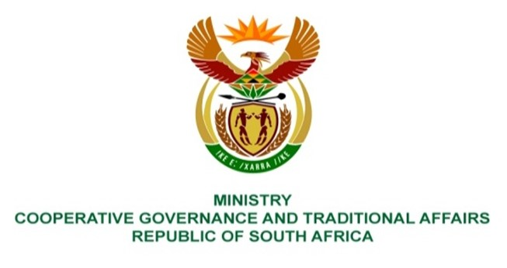

NATIONAL ASSEMBLY
QUESTIONS FOR WRITTEN REPLY

QUESTION NUMBER 299
DATE OF PUBLICATION: 07 MAY 2021

1851. Mr M J Cuthbert (DA) to ask the Minister of Cooperative Governance and Traditional Affairs:

Whether her department has any other projects in the pipeline for Lindelani Informal Settlement in terms of the provision of (a) electricity, (b) water and (c) sanitation; if not, what is the position in this regard; if so, what are the relevant details? NW2079E

REPLY:
The response is received from Ekurhuleni Metropolitan Municipality; the Lindelani informal settlement is currently provided with basic services such as water, sanitation, refuse removal, grading of the streets and mobile community services.
Further to the above, the residents of Lindelani informal settlement are earmarked to benefit from the two housing projects which are currently in the implementation phase, namely Alliance Extension 1 which entails the construction of houses and Alliance Extension 9 which entails the provision of serviced sites.
The allocation of completed houses at Alliance Extension 1 is in progress, whereas the construction of serviced sites and allocation thereof has not commenced. No electricity will be provided for the beneficiaries of houses and serviced sites as per the applicable policy.
However, the residents of Lindelani informal settlements who did not benefit in the Alliance Extension 1 and Alliance Extension 9 projects will be considered for the provision of water, sanitation and electricity when the informal settlement is re-blocked. The re-blocking will take place once the relocation has been finalised.

