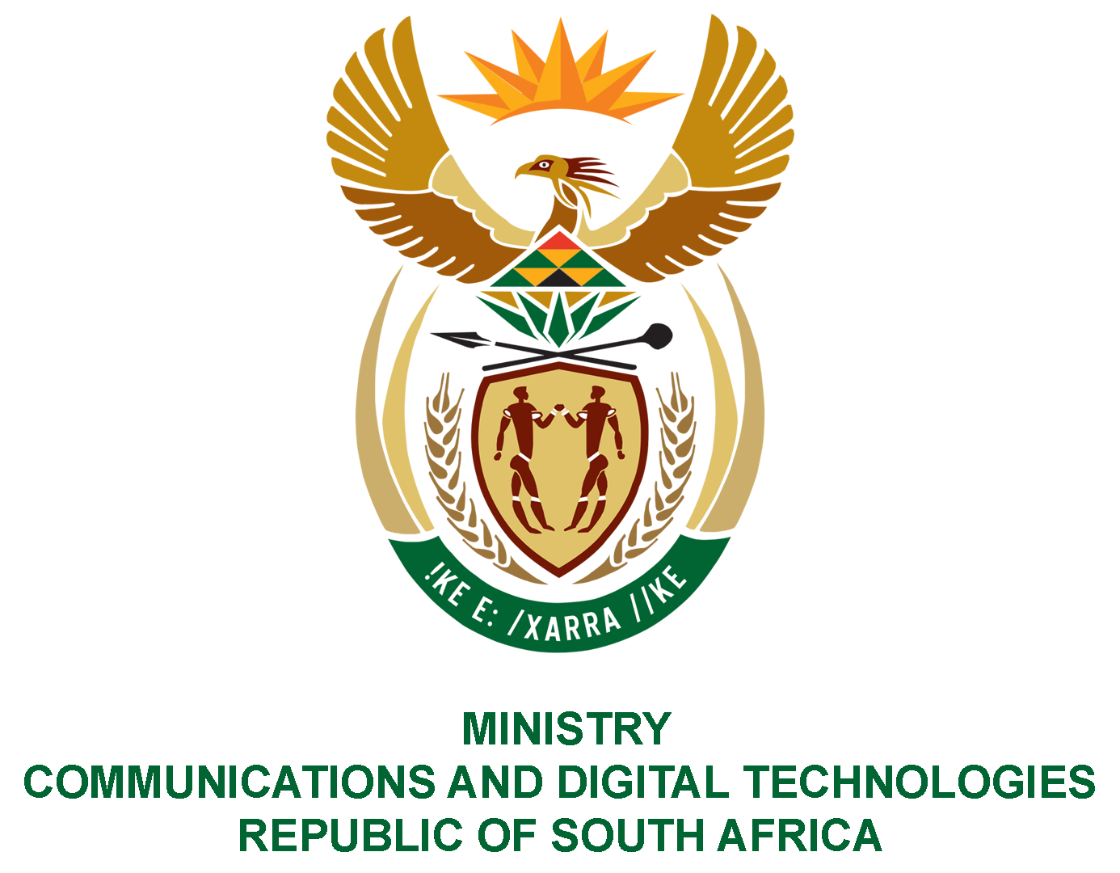
PARLIAMENT OF THE REPUBLIC OF SOUTH AFRICA
NATIONAL ASSEMBLY
WRITTEN REPLY

QUESTION NO: 185
DATE OF PUBLICATION: 11 February 2021
QUESTION PAPER NO: 01
Mr C MacKenzie (DA) to ask the Minister of Communications:
With reference to the Independent Communications Authority of South Africa and the annual renewal of certain electronic communication licences that were awarded and for which payment was made on 28 July 2020, but have not been received (details furnished), (a) on what date(s) were the specified licences issued for 2020, (b) on what date can the clients expect to receive the licences and (c) by what means are actual licences delivered to successful applicants?
NW188E
REPLY
I have been advised by the ICASA as follows:
License Numbers
District Monitoring-License numbers 545-461-2 and 552-562-1
District Watch-License numbers 493-819-8, 145-617-2 and 483-730
District Bassetti-License numbers 532-539-4

- ICASA issued all invoices for the annual Radio Frequency Spectrum (RFS) licence fees in respect of the RFS licences for the 2020-21 financial year on 22 July 2020. A batch of RFS Licences – including those held by District Watch, District Basset and District Monitoring - were printed on 29 November 2020.
- The printed RFS licences are posted to licensees by the Authority’s service provider via unregistered postage. However, in light of the question posed it is apparent that the licensees may not have received their licences via post. The Authority will contact the licensees to arrange a reprint of the RFS licences for delivery or collection by the licensees at the Authority’s offices.
- As stated above, printed RFS licences are posted to licensees by a service provider via unregistered postage. The Authority has however, noted the inefficiencies of this process and is currently implementing a new system (an Automated Spectrum Management System (“ASMS”)) for the processing of applications / renewals and delivery of RFS licences.

The ASMS system provides an online portal for receipt of – amongst others - new and renewal applications. The ASMS automatically sends invoices for administrative and licence fees via e-mail to the applicants as required. The system also automatically issues the RFS licences and e-mails them to successful applicants once processing and verification processes have been finalised. Going forward – with effect from 1 April 2021 - licensees will be able to download copies of their licenses from the ASMS and will no longer require the Authority to post licenses.

MS. STELLA NDABENI-ABRAHAMS, MP
MINISTER OF COMMUNICATIONS AND DIGITAL TECHNOLOGIES

