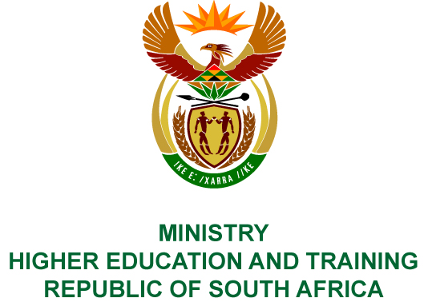
Private Bag X893, Pretoria, 0001, Tel (012) 312 5555, Fax (012) 323 5618
Private Bag X9192, Cape Town, 8000, Tel (021) 469 5150, Fax: (021) 465 7956
Memorandum from the Parliamentary Office
NATIONAL ASSEMBLY
FOR WRITTEN REPLY
QUESTION 185
DATE OF PUBLICATION OF INTERNAL QUESTION PAPER: 08/02/2018

(INTERNAL QUESTION PAPER NO 1 OF 2018)
Dr S S Thembekwayo (EFF) to ask the Minister of Higher Education and Training:
(a) What (i) is the number and (ii) are the names of (aa) institutions and (bb) projects at each institution that have been funded under the Humanities Hubs programme of the National Institute for Humanities and Social Sciences and (b) what (i) was/is the length of each project, (ii) was the funding period of each project and (iii) activities were held by each project?
NW192E
REPLY:
The National Institute for Humanities and Social Sciences (NIHSS) has provided the following responses to the questions posed.
(a) (i) Eight projects have been funded under the Humanities Hubs Programme as indicated in the table below.
Nr. | (a)(ii)(aa)  Name of Institution | (a)(ii)(bb)  Name of Project | (b)(i)  Length of Project | (b)(ii)  Funding Period | (b)(iii)  Activities of the project
 | Liliesleaf Trust Humanities Hub | Liberation Struggle Histories Hub | 3 years | 1/08/2014 – 31/08/2017 | - Colloquium  - Schools outreach  - Mobile exhibition at UNISA, UL & UNIVEN
 | Freedom Park | Freedom and Humanity Hub | 1 year | 1/4/2017 – 31/03/2018 | - Conduct educational programme  - Host story telling / oral history performance  - Establish Pan African Archives  - Collaborate with the University of Sol Plaatje, University of South African & University of Mpumalanga
 | University of Fort Hare, Liberation Struggle History Archives | Community Based Memories Humanities Hub | 3 years | 1/4/2017 – 31/03/2020 | Digitize the following hubs and sites:  - Lwandle Museum  - Alice Community Museum  - Hogsback Community Art Gallery  - Mgwali Forced Removal Community Museum  - Legal Offices of Robert Sobukwe in Graaff Reinet  - Home of Steve Biko, Ginsberg, Z.K. Matthews House, Alice.
 | Isimangaliso Wetland Park Authority | Isimangaliso Humanities Hub | 1 year | 1/4/2017 – 31/03/2018 | - Development of Digital Archive  - Publication of edited volume  - Publication of journal articles  - Capacity building, particularly for designated groups
 | Lwandle Migrant Labour Museum | Migrant Workers' Humanities Hub | 2 years | 1/4/2017 – 31/03/2019 | - Conduct a travelling exhibition  - Produce a DVD or booklet on the museum  - Collaborate with Kuyakhanya Production, University of Fort Hare & University of KwaZulu-Natal
 | Mapungubwe National Park & World Heritage | Mapungubwe Cultural Humanities Hub | 1 year | 1/4/2017 – 31/03/2018 | - Host a conference  - Host a Dialogue  - Capacity building particularly for designated racial and gender groups
 | The Hunterstoun Heritage Centre, University of Fort Hare | Land and Intellectual Humanities Hub | 1 year | 1/4/2017 – 31/03/2018 | The project will yield the following:  - Colloquium proceedings & two journal articles or chapters in books arising out of the colloquium  - Fifteen recorded accounts of the educational histories and experiences in the Eastern Cape of individual participants and their families  - Produce a documentary film based on these recorded histories  - An archive (video recordings and transcribed documents) of at least six recorded interviews with local people about their family’s history with regard to land
 | WITS Origins Centre | Origins Humanities Hub | 1 year | 1/4/2017 – 31/03/2018 | - Installation of Engraved Boulders  - Coordinate public visits  - Host Workshops  - Procure educational materials  - On Reflection of the contribution of Africa to world civilisations  - Update Blombos exhibition and Middle Age fossil discoveries on the Cape Coast  - Conduct community workshop  - Conduct Education seminar

COMPILER DETAILS
NAME AND SURNAME: MS PEARL WHITTLE
CONTACT: 012 312 5248
RECOMMENDATION
It is recommended that the Minister signs Parliamentary Question 185.

MR GF QONDE
DIRECTOR–GENERAL: HIGHER EDUCATION AND TRAINING
DATE:

PARLIAMENTARY QUESTION 185 IS APPROVED / NOT APPROVED / AMENDED.
COMMENT/S

PROF HB MKHIZE, MP
MINISTER OF HIGHER EDUCATION AND TRAINING
DATE:

