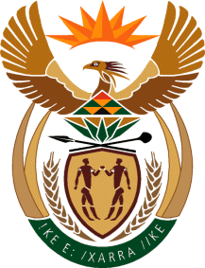

MINISTRY OF TOURISM
REPUBLIC OF SOUTH AFRICA

Private Bag X424, Pretoria, 0001, South Africa. Tel. (+27 12) 444 6780, Fax (+27 12) 444 7027
Private Bag X9154, Cape Town, 8000, South Africa. Tel. (+27 21) 469 5800, Fax: (+27 21) 465 3216

NATIONAL ASSEMBLY:

QUESTION FOR WRITTEN REPLY:
Question Number: 1848
Date of Publication: 20 August 2021
NA IQP Number: 17
Date of reply: 22 October 2022

Mr M S F de Freitas (DA) to ask the Minister of Tourism:
(a) What (i) internal investigations has her department undertaken into the drowning of an adventure river guide on the Storms River near Tsitsikamma in the Eastern Cape on 26 September 2020, (ii) is the deadline for the conclusion of the internal investigation and (iii) are the terms of reference for the investigation and (b) who is undertaking such an investigation?
NW2073E

REPLY:

(a)– (b) No investigation was done by the Department of Tourism, as it is not within its mandate.

.

