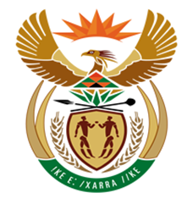

NATIONAL ASSEMBLY

QUESTION FOR WRITTEN REPLY
QUESTION NUMBER: 1842 [NW2050E]
DATE OF PUBLICATION: 19 JUNE 2017

1842. Mr M G P Lekota (Cope) to ask the Minister of Finance:

Whether he has ever opened or had a bank account in the United Arab Emirates; if so, (a) what are or were the circumstances relating thereto and (b) does the account still exist? NW2050E
REPLY:

(a-b) No.

