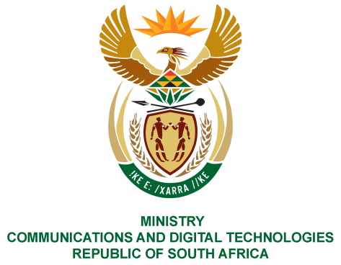
PARLIAMENT OF THE REPUBLIC OF SOUTH AFRICA
NATIONAL ASSEMBLY
WRITTEN REPLY

QUESTION NO: 184
DATE OF PUBLICATION: 11 February 2021
QUESTION PAPER NO: 01
Mr C MacKenzie (DA) to ask the Minister of Communications:
(1) (a) Why and (b) for how long has the electricity been turned off at the Reygersdal Post Office in Atlantis;
(2) What steps are being taken to ensure power is restored?
(3) What steps are being taken to ensure a backup power system is put in place?
NW187E
REPLY:
I have been advised by the SAPO as follows:

1. (a) The Reygersdal branch’s electricity was disconnected due to cable theft in the area.
(b) The electricity was disconnected in mid-January 2021.

2. The electricity has since been restored.

3. The disconnection of electricity due to cable theft can not be predicted and planned for due to its nature. However, in instances where cable theft unexpectedly occurs, the Municipality is contacted to ensure urgent restorative maintanance to avoid prolonged disruption of services.

MS. STELLA NDABENI-ABRAHAMS, MP
MINISTER OF COMMUNICATIONS AND DIGITAL TECHNOLOGIES

