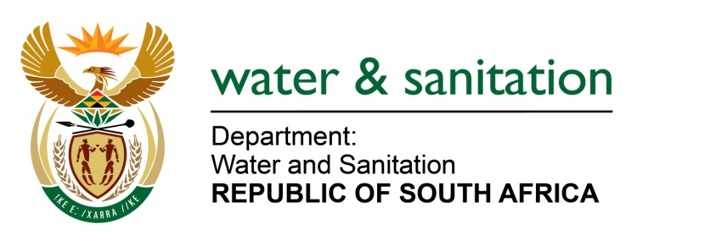

NATIONAL ASSEMBLY

FOR WRITTEN REPLY

QUESTION NO 1835

DATE OF PUBLICATION IN INTERNAL QUESTION PAPER: 13 MAY 2022
(INTERNAL QUESTION PAPER NO. 17)

1835. Mrs T P Msane (EFF) to ask the Minister of Water and Sanitation:

By what date will his department (a) fix the boreholes in Ward 23 and 27 in Giyani and/or (b) assist the Greater Giyani Local Municipality to ensure that people living in the specified wards have access to water?

NW2168E
---00O00---
MINISTER OF WATER AND SANITATION

- The Department of Water and Sanitation (DWS) together with the Mopani District Municipality are in the process of implementing a number of interventions to ensure that communities living in the Greater Giyani Local Municipality have access to water. The projects entail refurbishment of Giyani water treatment works required to treat surface water from the Nsami Dam and to convey adequate and sustainable potable water to Giyani Town and the surrounding 55 villages. The projects progress is as follows

PRPOJECT NAME | DESCRIPTION OF PROJECT | OVERALL CONSTRUCTION PROGRESS IN % | ANTICIPATED COMPLETION DATE
Giyani water services – reticulation  Funded by the Mopani District Municipality (MDM) | - Refurbishment/construction of service reservoirs in 55 villages  - Refurbishment/construction of reticulation in 55 villages around Giyani  - Installation of metered yard connections for revenue enhancement & demand management | 0% it is at planning state | TBC
Giyani water treatment works refurbishment  Funded by MDM | - Minor refurbishment of the operational 30Ml/d WTW components  - Major refurbishment of non-operational 6,5Ml/d WTW components | 0% it is at planning state | September 2023
Giyani water services – bulk distribution  Funded by DWS | - Construction of eight (8) bulk pipelines to provide water to 55 villages (325 km)  - Repairs and refurbishments of existing water and sanitation infrastructure | 53% | December 2022
Nandoni to Nsami pipeline  Funded by DWS | - Construction of 49km raw water pipeline to Giyani | 40% | September 2023

The MDM has 346 newly drilled boreholes that require electrification. Applications for electrification of boreholes have been submitted to ESKOM. The district municipality indicated that electrical installations will be done in batches of 25 boreholes due to budget constraints.

Bulk water from the Nondweni water treatment works is reaching all the villages. The Mopani District Municipality is also constructing a booster pump station to ensure that water reaches the furthest point especially the Mayephu area. The booster pump station is 80% complete.

---00O00---

