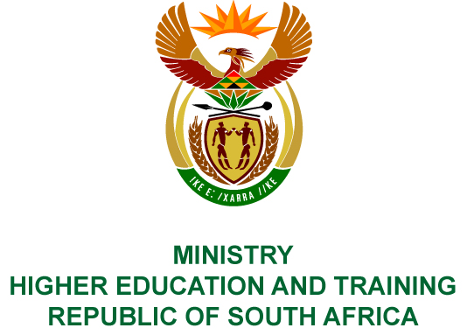
Private Bag X893, Pretoria, 0001, Tel (012) 312 5555, Fax (012) 323 5618
Private Bag X9192, Cape Town, 8000, Tel (021) 469 5150, Fax: (021) 465 7956
Memorandum from the Parliamentary Office
NATIONAL ASSEMBLY
FOR WRITTEN REPLY
QUESTION 183
DATE OF PUBLICATION OF INTERNAL QUESTION PAPER: 08/02/2018

(INTERNAL QUESTION PAPER NO 1 OF 2018)
Mr L G Mokoena (EFF) to ask the Minister of Higher Education and Training:
Does the National Institute for Humanities and Social Sciences have any outstanding payments for students who have been granted a scholarship for the 2017 academic year; if so, (a) what number of students, (b) what amount is outstanding in each case and (c) what is delaying payment for the students?
NW190E
REPLY:
The National Institute for Humanities and Social Sciences (NIHSS) has provided the following responses to the questions posed.
- As at 10 November 2017, the NIHSS had a total of 59 doctoral students whose payments for the 2017 academic year had not yet been released.
- The total outstanding amount for the 59 students is R6 798 000.00. The outstanding amount for each student is indicated in the attached table.
- There are various reasons for non-payment, including outstanding documents from students. In addition, as at 10 November 2017, the NIHSS was still awaiting a transfer of funds from the National Skills Fund to support the scholarships. The reasons for each student is indicated in the attached table.

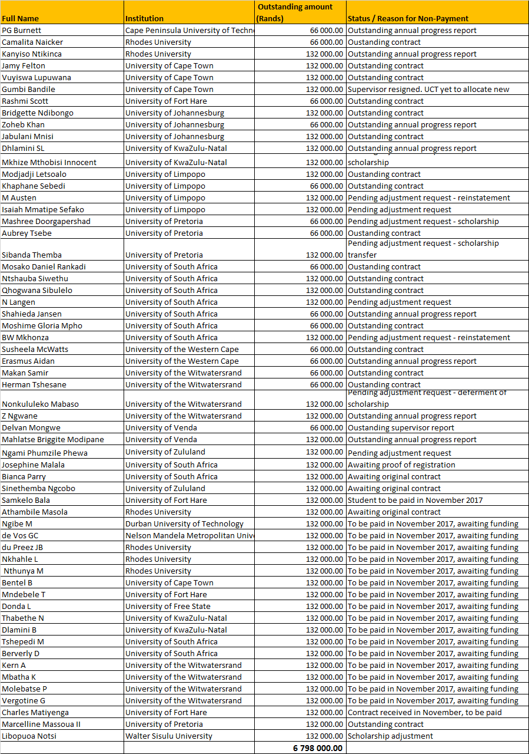
COMPILER DETAILS
NAME AND SURNAME: MS PEARL WHITTLE
CONTACT: 012 312 5248
RECOMMENDATION
It is recommended that the Minister signs Parliamentary Question 183.

MR GF QONDE
DIRECTOR–GENERAL: HIGHER EDUCATION AND TRAINING
DATE:

PARLIAMENTARY QUESTION 183 IS APPROVED / NOT APPROVED / AMENDED.
COMMENT/S

PROF HB MKHIZE, MP
MINISTER OF HIGHER EDUCATION AND TRAINING
DATE:

