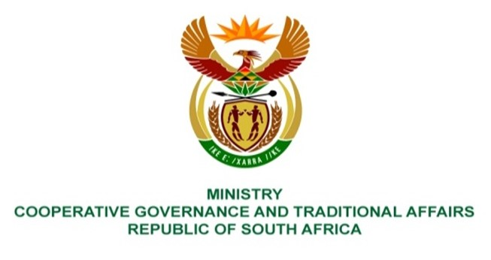

NATIONAL ASSEMBLY
QUESTIONS FOR WRITTEN REPLY

QUESTION NUMBER 1828
DATE OF PUBLICATION: 20 AUGUST 2021

QUESTION:

1828. Ms S A Buthelezi (IFP) to ask the Minister of Cooperative Governance and Traditional Affairs:
Whether she intends to extend legal protection to small businesses facing liquidity challenges as a result of the pandemic, similarly to the legal protection that was given to residential tenants and unlawful occupiers under the COVID-19 Regulations; if not, why not; if so, what are the relevant details? NW2051E

REPLY:
The issues relating to relief measures to small businesses facing liquidity challenges as a result of the pandemic are managed and administered by the Department of Small Business Development. The question needs to be redirected to the relevant department.

