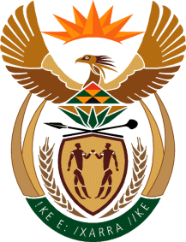

MINISTER IN THE PRESIDENCY: PLANNING, MONITORING AND EVALUATION
REPUBLIC OF SOUTH AFRICA
Private Bag X1000, Pretoria, 0001; Tel: 012 300 5200 / 021 464 2100

1827. Mr H B Groenewald (DA) to ask the Minister in The Presidency. (1 JUNE 2018)
Mr H B Groenewald (DA) to ask the Minister in The Presidency:
(1) Whether (a) her spouse and/or (b) an adult family member accompanied her on any official international trip (i) in each of the past five financial years and (ii) since 1 April 2018; if not, what is the position in this regard; if so, what (aa) is the name of the person(s), (bb) was the (aaa) purpose and (bbb) destination of the trip and (cc) was the (aaa) total cost and (bbb) detailed breakdown of the costs of the accompanying person(s) to her Office;
(2) whether each of the specified trips were approved by the President in terms of the provisions of Section 1, Annexure A of the Ministerial Handbook; if not, why not; if so, what are the relevant details? NW1986E

Reply to the question

- (a) No
(b) No
(i) No
(ii) No; I think that this matter is adequately covered by the ministerial handbook.
(aa) Not Applicable (bb) Not Applicable, (aaa) N/A, (bbb) N/A (cc) N/A
- Not Applicable.

Dr Nkosazana Dlamini Zuma, MP
Minister in the Presidency: Planning Monitoring and Evaluation
Date:

