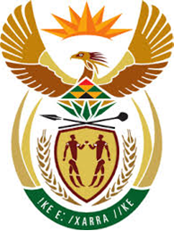

DEPARTMENT: PUBLIC ENTERPRISES
REPUBLIC OF SOUTH AFRICA

NATIONAL ASSEMBLY
QUESTION FOR WRITTEN REPLY
QUESTION NO.: 1822

QUESTION:
1822. Mr E M Buthelezi (IFP) to ask the Minister of Public Enterprises:
(1) What is the status of finalising the strategic equity partnership between SA Airways (SAA) and a certain company (name furnished), that would acquire 51% in SAA;
(2) whether an amendment to the Memorandum of Incorporation of SAA has been concluded; if not, why not; if so, what are the relevant details
NW2045
REPLY:
- The due diligence is at an advanced stage and should be completed shortly. The parties have started negotiating the Sale and Purchase Agreement (SPA). After the successful completion of the SPA stage, we will be able to announce the completed deal to the public pending regulatory approval.
- Once the Sale and Purchase Agreement have been concluded, the Memorandum of Incorporation will be finalised.

