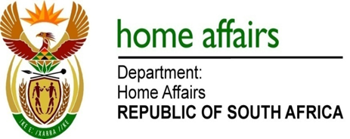

NATIONAL ASSEMBLY

QUESTION FOR WRITTEN REPLY

QUESTION NO. 1821

DATE OF PUBLICATION: FRIDAY, 1 JUNE 2018

INTERNAL QUESTION PAPER 19 OF 2018

1821. Mr S Esau (DA) to ask the Minister of Home Affairs:

(1) Whether (a) his spouse and/or (b) an adult family member accompanied him on any official international trip (i) in each of the past five financial years and (ii) since 1 April 2018; if not, what is the position in this regard; if so, what (aa) is the name of the person(s), (bb) was the (aaa) purpose and (bbb) destination of the trip and (cc) was the (aaa) total cost and (bbb) detailed breakdown of the costs of the accompanying person(s) to his department;
(2) whether each of the specified trips were approved by the President in terms of the provisions of Section 1, Annexure A of the Ministerial Handbook; if not, why not; if so, what are the relevant details? NW1980E
REPLY:

(1-2) Yes, the Ministerial Handbook allows for a Minister to be accompanied by his wife and I do not have to seek the president’s permission for that. However, I can choose my wife or any of my children to accompany me in place of my wife.

I have not been accompanied anywhere by my wife or any member of my family in the only international trip I have undertaken since 1 April 2018

