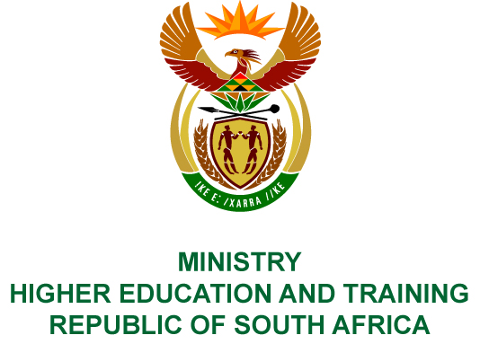
Private Bag X893, Pretoria, 0001, Tel (012) 312 5555, Fax (012) 323 5618
Private Bag X9192, Cape Town, 8000, Tel (021) 469 5150, Fax: (021) 465 7956
Memorandum from the Parliamentary Office
NATIONAL ASSEMBLY
FOR WRITTEN REPLY
QUESTION 1820
DATE OF PUBLICATION OF INTERNAL QUESTION PAPER: 01/06/2018
(INTERNAL QUESTION PAPER NO 19 OF 2018)
Mr S Esau (DA) to ask the Minister of Higher Education and Training:
(1) Whether (a) her spouse and/or (b) an adult family member accompanied her on any official international trip (i) in each of the past five financial years and (ii) since 1 April 2018; if not, what is the position in this regard; if so, what (aa) is the name of the person(s), (bb) was the (aaa) purpose and (bbb) destination of the trip and (cc) was the (aaa) total cost and (bbb) detailed breakdown of the costs of the accompanying person(s) to her department;
(2) whether each of the specified trips were approved by the President in terms of the provisions of Section 1, Annexure A of the Ministerial Handbook; if not, why not; if so, what are the relevant details?
NW1979E
REPLY:
- The Minister undertook two official international trips since her appointment as the Minister of Higher Education and Training. On none of these trips was the Minister accompanied by members of her family.
The Minister travelled to Tunis in Tunisia to participate in the Islamic Development Bank Scientific Advisory Board meeting from 31 March 2018 to 4 April 2018. The organisers covered all flights and accommodation costs, while the Department only covered the daily allowance of the Minister.
The Minister also travelled to the Netherlands to attend the 15th Anniversary Celebration of the Prince Claus Chair on 12 April 2018 and was accompanied by two Departmental officials.
- The President approved both trips.

