MINISTER OF DEFENCE AND MILITARY VETERANS
NATIONAL ASSEMBLY (NA)
QUESTION FOR WRITTEN REPLY
QUESTION NUMBER 182
DATE OF PUBLICATION: 10 February 2022
REPLY RECOMMENDED BY:
MINISTER OF DEFENCE AND MILITARY VETERANS: MP

2
NATIONAL ASSEMBLY (NA)
QUESTION NUMBER 182
DATE OF PUBLICATION: 10 FEBRUARY 2022
Dr N.V. Khumalo (DA) to ask the Minister of Defence and Military Veterans
a) What number of supplier invoices currently remain unpaid by (i) her department
and (ii) each entity reporting to her for more than (aa) 30 days, (bb) 60 days, (cc)
90 days and (dd) 120 days?
b) What is the total amount outstanding in each case?
c) By what date is it envisaged that the outstanding amounts will be settled?
REPLY:
1) Response to Paragraph (a)
As at 14 February 2022 the DOD had Three Thousand Nine Hundred and Thirty-Six (3936) unpaid
invoices.
(aa)
(bb) Suppliers invoices currently unpaid and older than 30 days (96)
(cc) Suppliers invoices currently unpaid and older than 60 days (35)
Suppliers invoices currently unpaid and still within the 30 days (3526)
(dd) Suppliers invoices currently unpaid and older than 90 days (204)
(ee) Suppliers invoices currently unpaid and older than 120 days (75)
2)
Response to Paragraph (b)
(aa) Suppliers’ invoices currently unpaid and are still within 30 days payment period amounts to
RM 188 400 872.01
(bb) Suppliers’ invoices currently unpaid and are already over the 30 days payment period
amounts to RM 14 131 214.52
(cc) Suppliers’ invoices currently unpaid and are already over the 60 days payment period
amounts to R 392 467.30
(dd) Suppliers’ invoices currently unpaid and are already over the 90 days payment period
amounts to R 139 133.27
(ee) Suppliers’ invoices currently unpaid and are already over the 120 days payment period
amounts to RM 3 120 208.38

ARMSCOR
> 30 days
Invoices
> 60 days
Invoices
> 90 days
Invoices
> 120 days
ENTITY
Invoices
Amount
> 60 days
> 90 days
> 120 days
Armscor
operational
4
R
R
16 449,93
4
R
R
14 071,28
1
R
9 890,00
1
R
R
7 256,50
DOD projects
18
14 368 341,07
7
628 627,85
6
7
R687 639,54
R 697 529,54
59
11 564 523,83
Total
outstanding
R
14 384
22 791,00
11
R
642 699,13
60
R
11 571 780,33
Invoices not paid within 30 days due to outstanding contractual compliance matters before payment can be done (e.g.
Quality acceptance outstanding, proof of delivery not received, outstanding contractual documentation for payment).
Invoices will be paid once contractual conditions are complied with.
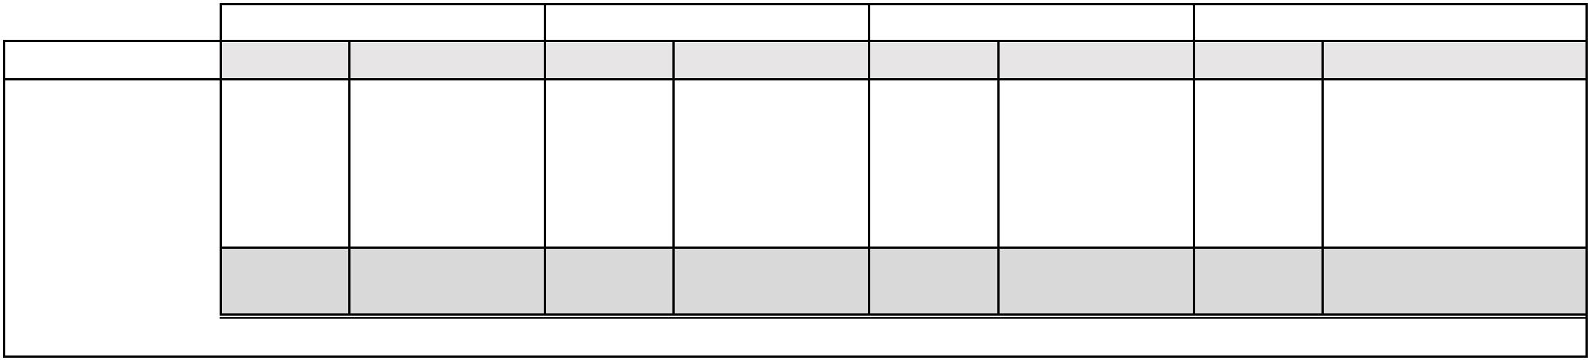

CASTLE CONTROL BOARD
1) (aa, cc, dd). As of 21 February 2022, there are no unpaid or outstanding invoices
in the categories of 30, 90, and 120 days.
2) (bb) Suppliers’ invoices currently unpaid and already over than 60 days brackets is
one (1) and the amount is R4 205, 88.
DEPARTMENT OF MILITARY VETERANS
Specifically for the month of January 2022, the department of Military Veterans paid 100% or 92
invoices in respect of the purchase orders issued. The non-compliance rate was 0%. However,
the department paid 96, 07% or 1001 for benefits related invoices. The non-compliance rate was
3, 93% or 41 invoices.
It is also acknowledged that TWF invoices amounting to R7 million are due for validation and
payment thereafter. The invoices are dated as back as in 2018 therefore sufficient time is required
to scrutinize invoices to avoid duplicate payments.
The department intends to settle all outstanding accounts by 31 March 2022.
3)
Response to Paragraph (c)
a. All legitimate invoices that are above the 30, 60, 90, and 120 days payment
period would be prioritised and be paid on or before 31 March 2022, as this
date is the financial year closure by which all invoices of this current financial
year should have been paid.
4)
Conclusion:
A Number of interventions and actions are being undertaken by management to improve
the payment turnaround time in order to fully comply with the requirements of the PFMA,
e.g.:
a. Instead of only having a Payments Compliance Forum at Corporate Level,
Regional Compliance Forums have been introduced to address payments
challenges at every entry point of invoices within the Department in order to
expedite the processing thereof.

5
b. While the DOD procurement systems are not fully integrated with the Invoice
Payment System, the Financial Management system (FMS), the FMS has been
enhanced to the enable invoices tracking ability, this enhancement makes it
easier to expedite payment of invoices that are about to reach the threshold of
30 days.
c. State Information Technology Agency (SITA) in conjunction with DOD’s
Command and Management Information Systems division (CMIS), this is the
Department’s IT Division, are busy developing an integrated dashboard that will
enable any Manager/ Commander at any level in the Department to be able to
track procurement matters in their Unit, thereby enhancing the accountability
chain throughout the Department with regard to processing of invoices.
d. The Secretary for Defence and C SANDF, co-chair a departmental forum called
the Accountability Management Committee (AMC), which amongst others is
seized with the responsibility of ensuring that there is full compliance with rules
and regulations of administration in totality in the department, including the
payment of suppliers invoices within 30 days.
e. Other operational measures implemented to expedite payments of invoices is
the authorisation of overtime work by management from time to time to staff
members, processing invoices depending on volumes that are at hand at each
point in time. This strategy is also applied in all areas in the finance division
where there is staff shortage as a result of personnel budget cuts and
constraints including capacity constraints brought about by indisposition of
officials as a result of Covid-19 ailments.
