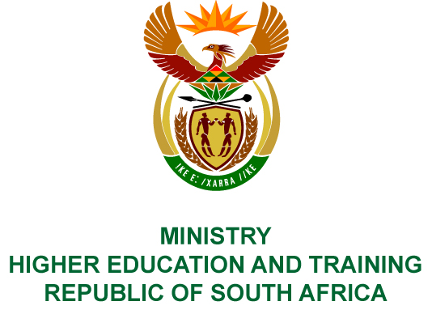
Private Bag X893, Pretoria, 0001, Tel (012) 312 5555, Fax (012) 323 5618
Private Bag X9192, Cape Town, 8000, Tel (021) 469 5150, Fax: (021) 465 7956
Memorandum from the Parliamentary Office
NATIONAL ASSEMBLY
FOR WRITTEN REPLY
QUESTION 182
DATE OF PUBLICATION OF INTERNAL QUESTION PAPER: 08/02/2018

(INTERNAL QUESTION PAPER NO 1 OF 2018)
Ms N P Sonti (EFF) to ask the Minister of Higher Education and Training:
What number of scholarships were signed by the National Institute for Humanities and Social Sciences in 2016 with regard to the (a) course of study, (b) gender of the scholarship recipient, (c) race of the scholarship recipient, (d) institution where the study was undertaken and (e) value of each scholarship?
NW189E
REPLY:
The National Institute for Humanities and Social Sciences (NIHSS) has provided the following responses to the questions posed.
The NIHSS awarded 469 scholarships in the 2016 academic year.
- Funded students were registered in the broad field of Humanities and Social Sciences, covering approximately 50 disciplines.
- Of the 469 scholarships awarded, 259 were females and 210 were males.
- African = 347
Coloured = 40
Indian = 29
White = 53
- The breakdown of students supported per institution is shown in the table below:
No. | Institution | Students
 | Cape Peninsula University of Technology | 1
 | Durban University of Technology | 4
 | Nelson Mandela University | 15
 | North West University | 15
 | Rhodes University | 22
 | Stellenbosch University | 24
 | Tshwane University of Technology | 2
 | University of Cape Town | 37
 | University of Fort Hare | 33
 | University of Free State | 6
 | University of Johannesburg | 15
 | University of KwaZulu-Natal | 94
 | University of Limpopo | 22
 | University of Pretoria | 26
 | University of South Africa | 29
 | University of the Western Cape | 27
 | University of Venda | 27
 | University of the Witwatersrand | 62
 | University of Zululand | 7
 | Walter Sisulu University | 1
Grand Total |  | 469
- The value of the doctoral scholarships in 2016 was R132 000 per student.

COMPILER DETAILS
NAME AND SURNAME: MS PEARL WHITTLE
CONTACT: 012 312 5248
RECOMMENDATION
It is recommended that the Minister signs Parliamentary Question 182.

MR GF QONDE
DIRECTOR–GENERAL: HIGHER EDUCATION AND TRAINING
DATE:

PARLIAMENTARY QUESTION 182 IS APPROVED / NOT APPROVED / AMENDED.
COMMENT/S

PROF HB MKHIZE, MP
MINISTER OF HIGHER EDUCATION AND TRAINING
DATE:

