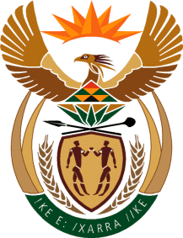

MINISTRY OF TOURISM
REPUBLIC OF SOUTH AFRICA

Private Bag X424, Pretoria, 0001, South Africa. Tel. (+27 12) 444 6780, Fax (+27 12) 444 7027
Private Bag X9154, Cape Town, 8000, South Africa. Tel. (+27 21) 469 5800, Fax: (+27 21) 465 3216

NATIONAL ASSEMBLY:

QUESTION FOR WRITTEN REPLY:
Question Number: 1819
Date of Publication: 20 August 2021
NA IQP Number: 17
Date of reply: 22 October 2021

Mr K P Sithole (IFP) to ask the Minister of Tourism:
Whether she has considered the issue of the Republic being placed on the red list in the United Kingdom about eight months ago and how does she intend resolve the matter of inbound tourism into the Republic and mend relations between the two nations; if not, why not; if so, what (a) are the relevant details and (b) plans are in place to expedite the resolution of the matter?
NW2042E

REPLY:

- and (b)
The department is aware of the red list. However, the department does not agree that the red list is a reflection on or has a bearing on UK – South Africa relationship. The department, South African Tourism and the industry will embark on an advocacy project to ensure that information regarding South Africa’s and in particular the industry’s management of the pandemic and efforts o support ease of travel facilitation is provided to travel trade, consumers and other inbound tourism stakeholders. This will be targeted at all our priority markets to ensure confidence building.

