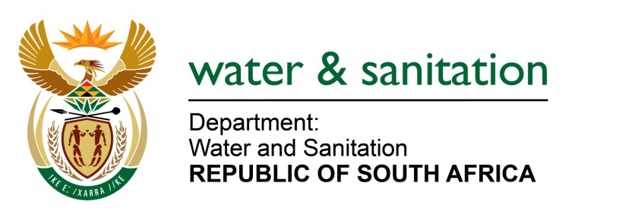

NATIONAL ASSEMBLY

FOR WRITTEN REPLY

QUESTION NO 1815

DATE OF PUBLICATION IN INTERNAL QUESTION PAPER: 9 SEPTEMBER 2016
(INTERNAL QUESTION PAPER NO. 27)

1815. Ms T E Baker (DA) to ask the Minister of Water and Sanitation:
(1) (a) What is the extent of the water infrastructure maintenance being undertaken in the Mopani District in Limpopo and (b) why did the cost of the specified project increase from R 94,4 million to R 502,6 million in three months;
(2) (a) Who has been appointed as contractor(s) on the specified project, (b) what amount has been paid to the specified contractor(s) to date and (c) what is the current status of the specified project;
(3) Did the specified project go out on tender; if not, why not; if so, (a) what are the names of the companies that made submissions for the specified tender and (b) what is the name of the company that was awarded the specified tender? NW2123E
---00O00---

REPLY:
(1)(a) In 2009, the Giyani area was officially declared a disaster zone as a result of terrible water and waste water situation. It was consequently adopted into the Presidential Siyahlola Programme. To redress the situation in Mopani, I issued an emergency directive in August 2014 to my Department’s Implementation Agent, i.e. Lepelle Northern Water to regularise water and sanitation provision in the Mopani District area.
In implementing the Directive, various projects were identified, categorised and prioritised in the Short - term/ critical emergency projects and the Medium - Long term projects as follows:
- Below are the short-term/ critical emergency projects that were completed.
- 16 Priority Villages Groundwater Augmentation;
- Nkhensani Hospital Groundwater Augmentation;
- Giyani WWTW 1.5Ml/day (package plant);
- Giyani WWTW (refurb-existing plant);
- Morogholo Transfer Pumpstation;
- Kremetart Transfer Pumpstation;
- Khanyisa Booster Pumpstation;
- Nsami Water Treatment Plant (Refurb of old plant);
- Nsami Water Treatment Plant (New) and;
- Kremetart High & Low Reservoirs.
In addressing the medium to long term and the sustainability of the Mopani area and its surroundings, a number of projects were identified. The identified projects are in different stages of planning and designs and implementation, such as:
- Nandoni – Nsami bulk pipeline project to augument water supply to Giyani Town and the project currently under implementation;
- Giyani bulk water pipelines (Pipeline A, B, C, D, F1 & F2) currently under implementation covering approximately 345km distance;
- Revitalization of existing 154 boreholes with package plants to augment the water scheme while the bulk pipelines in progress and project expected to be completed by December 2016;
- The designs of Giyani Reservoir 35ML, Giyani 14ML Waste Treatment plant, Giyani Village reticulation, Nandoni Water Treatment upgrade, Bambanana/ Nkambako bulk pipeline projects. The planning and designs have been completed and the projects are ready for implementation; and
- The design of the Namakgale Waste Water Treatment Plant is progressing well and expected to be finalised by end December 2016.
(1)(b) Over and above the designs and the implementation of the short-term/ critical emergency projects, Lepelle Northern Water is currently undertaking the Operation and Maintenance on existing and new infrastructure in Giyani Town which include material and/or equipment purchasing to refurbish dilapidated infrastructure.
The specified operation and maintenance is on-going as and when required on site to maintain the existing and new infrastructure until handed over to the Water Service Authority.
(2)(a) The contractor appointed by Lepelle Northern Water is LTE Consulting on a Turnkey basis for the project.
(2)(b) The approved budget for the Mopani Intervention project is R2.2 billion. Out of the approved budget an amount of R1 391 838.00 has been spent to date which include the amount of R57 million of the specified project i.e. operation and maintenance for the planning, designs and implementation of the Mopani Intervention project.
(2)(c) As indicated above, the short–term/ critical emergency projects have since been completed. The medium-long term projects are various planning, designs and implementation stages. The specified operation and maintenance is on-going as when required on site to maintain the existing and new infrastructure before is handed over to the Water Service Authority.
(3) Due to the emergency situation and the urgency to redress the water and sanitation in Mopani area the project did not go through the open tender process. However, the appointment of the Service Provider was completed through the close tender process using Department Panel. The specified project of operation and maintenance is part of the Mopani Intervention programme. As indicated in (2) above, LTE Consulting was appointed on a Turnkey basis for the project. We are convinced that the method used to appoint LTE Consulting is in line with SCM policy and National Treasury guidelines applicable to emergency/disaster situations.
---00O00---

